Tattooing: Primal Penmanship
I
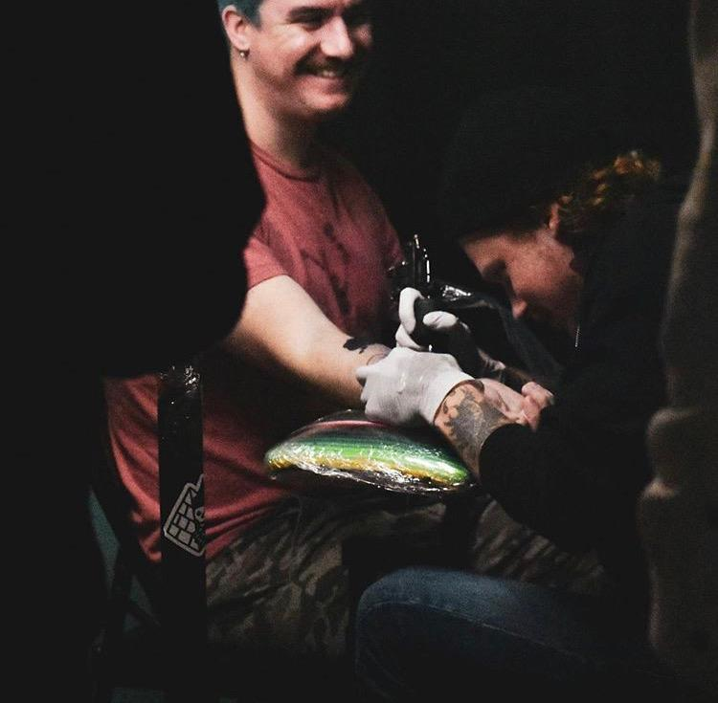
t's the last week of September,2019, and I decided it would be fun to get the top of my foot tattooed, because that'll look cool right? I walked into the shop that day not knowing what to expect, having simply booked an appointment and knowing that I would not have to worry about my newest addition.
Andrew Poss, an artist with Charleston Tattoo Company here in Charleston, presented a few options for what would look best on my foot and placed a stencil, warning that this was not about to be the most fun I had ever had.
Poss tattoos the right forearm of a “walk-in” customer
Soon after, he had set up his station and ask me to sit upright on his massage table, with my foot hanging off the edge so that he could access all available angles to work from. The sound of his rotary machine switching on filled the air in the shop and he asked, “you ready?”. Then laid down the outline of what would become an image of the grim reaper.
Writing has always been a living thing. Evolving through the ages to maintain its status as a field of study and disguising itself within our daily lives so as to never become extinct. In a digital age, the written word has become associated with text on a screen. However, since as early as the 5th millennium BC, human beings have utilized their own skin to record and preserve information.
In recent years, tattooer Andrew Poss has worked day and night to master the discipline and tools through which to transcribe his ideas onto the human body.
“…when approached to perform his craft for a client, Poss makes a point to ask as many questions as possible regarding style, sizing, placement, and coloration before moving forward.”
Not unlike writing, learning to tattoo effectively takes time and practice. After getting his first taste of tattoo culture in 2011, Poss began the pursuit of an apprenticeship, where he was able to rekindle his drive to create art and become a professional artist under the guidance of those who would offer it. Nine years later, he had honed in his process and is producing quality work on a regular basis.
As writers, in the sense we produce text on a page, we are familiar with our own creative process and the techniques with which to produce work within a given genre.
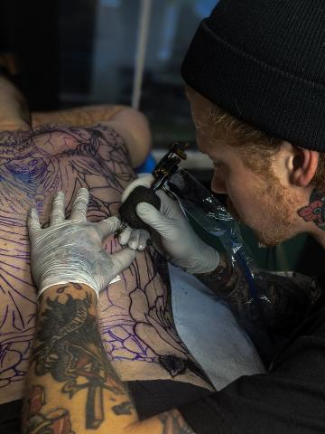
In the realm of tattooing, men like Andrew Poss have developed habits which relate closely to those which writers use to create a piece. For example, when approached to perform his craft for a client, Poss makes a point to ask as many questions as possible regarding style, sizing, placement, and coloration before moving forward. He does this in order to become clear on what his audience is expecting to get out of his work and to set a frame of reference for the resources he will pull from to produce the contracted piece.
Poss lays down heavy black line work in the first of many sessions for this client’s back piece
In order to tailor pieces to meet the specific needs of a client, a large amount of reference material is compiled. Ranging from one end of a genre to another. According to Poss, most art, in his experience comes to fruition through the use of reference material and over the course of several revisions.
In writing, we use an outline to guide us through to the conclusion of our work. Similarly, a line drawing is composed and the tattooer will work inward. Sometimes a simple outline is enough to complete a task, and other times more detail is required for completion.

To reach a complete draft of the piece, suitable to be submitted for review or to be used as a stencil, multiple revisions have to be made in the necessary areas for a line drawing to meet both the expectations of the artist and the client.
Creating meaningful work can be difficult. In a professional setting, Poss describes that near 90% of his jobs are contracted by the client and designed around their specific ideas. Meaning for him entails creating the best-looking image in relation to where it is placed on the client’s body. When doing a piece for himself, Poss feels more pressure in knowing that it will ultimately go into his professional portfolio.
Stamping ink into a skin canvas is a very primal form of writing. Technology in writing has led us to the use of pen and paper, keyboards, and stylus, even emojis as a form of text to convey meaning to others. Originally, a treated leather called vellum, or preserved calf skin, was used as a surface for transcription dating as far back as the 24th century BC. While the tools appear different and are obviously more advanced, the concept remains the same: an expert in the art of transcription inserts ink into a treated section of skin.
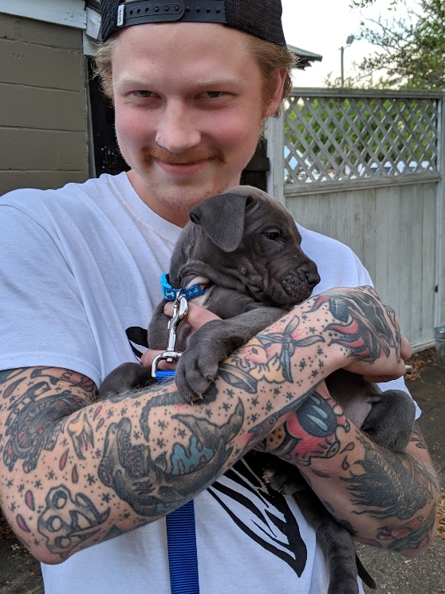
Tattooing is a function and form of the writing discipline. We see the similarities in the process from start to finish, differing only in genre and subject matter.
Upon assignment of a piece an artist, or writer, will establish a sense of how to meet their audience’s expectations, create a guiding element, revise, and ultimately produce. The technologies involved in each practice appear very dissimilar, though a writing environment might resemble a tattoo booth more than we think.
Poss after completing a session
Tattooing as a discipline has come to be from the most basic of writing practices and preserves the technique which has evolved into what we see today as a text on a screen, rather than marks on the skin.

