The Tik Tok Trend
Will Authenticity Override Photoshop?

U

p until July 2019, fifteen-year-old, Charlie D'Amelio, was just an everyday teenager. One sunny, summer day, this Connecticut dancer's life was forever changed. If you are a frequent Tik Toker, you may have seen her dancing all over your For You Page.

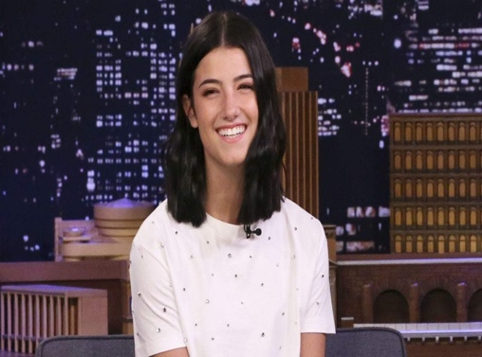
Charlie is known primarily for her creative dances, natural looks, and lip-syncing talents. She was a competitive dancer since she was a young girl, and actually began using the video app as an outlet to post her dancing. Ever since last July, her account exploded with popularity, and her following has grown to over 41 million.
Charli D'Amelio

Potentially, anyone who has downloaded a social media app could wake up one morning with over six million new followers.

Social media applications such as Tumblr, VSCO, and Pinterest--all relevant forms of marketing--have seen a recent decline over the last three years due to the constant idealized images posted by social media influencers.

According to Marketing Land, “only 52 percent of global respondents trust businesses. The figures are even more dramatic in the US, where a mere 48 percent are similarly trusting, down from 58 percent in 2017. Brands clearly need to re-evaluate their messaging strategies if they are to regain the public’s confidence,” arguing that “Brands strive for authenticity as audiences turn a skeptical eye towards ads.”

Over the years, there has been a rise in influencer marketing on social media applications. These influencers are seen as the epitome of perfection, according to Sofie Tapia from the Bored Panda. Tapia discusses the thoughts of those individuals seeking perfection as seen on an Influencer’s Instagram feed, “Researchers found that “fitspiration” images in particular – which often feature beautiful people performing exercises, or at least pretending to – might make you harsher on yourself.”

By using editing tools such as Photoshop and Face tune, these influencer’s photos can be a deception of “real life.” Rianne Meijer shared a series of photos of herself side by side to ones taken in the same outfit, but with a more realistic approach. Her caption read:

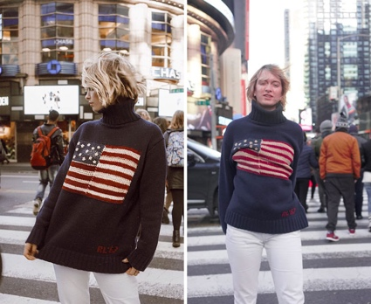
“So while waiting here at the airport in Berlin I figured no better way to spend my time than to keep it real. This is not gonna be some long emotional story (not that there’s anything wrong with crying and talking to yourself in the shower obviously) but just a little small reminder that every pic you see on my account is one in a hundred (or sometimes four hundred) and it was all about the right angle, right lighting and of course the right filter. Nothing perfect about me and nothing perfect about my life (except for @royatiya, and my parents). Just a girl with big dreams who’s going to regret posting this in 1,2,3..."
Instagram VS. Reality
Despite the features of a typical Instagram model, the everyday individual does not necessarily have an hourglass figure or a spotless face. As a result, thus individuals are looking for brands who are not afraid to market the “real girl,” as opposed to the idealized one.

Tik Tok has become the media app that values this sense of authenticity over the ‘skinny’ photoshopped culture. says R/GA, Amelia Westerburg.

Social media applications have the potential to lose their popularity over time, however, according to TodayCreative, “Instagram and Snapchat are the only two social platforms to have maintained their growth, largely in the youth segment over the last couple of years in the US. There are other content platforms that are on the rise, like TikTok and YouTube (still!).”

As Tik Tok increases in popularity over all age spectrums, brands have begun to seek out influencers who have a large following on this application. Brands such as Calvin Klein and Crocs have created campaigns where girls and boys can post videos wearing their clothes and they have an opportunity to end up on their feed while also accessing free clothes, discount codes, and opportunities to become brand ambassadors.

Tik Tok provides individuals with an outlet to freely express themselves in a variety of ways such as: singing, dancing, art, and speaking. Individuals have the opportunity to connect with other users from across the globe on a deeper level than other social media applications through the apps “Duet” function.

In an interview conducted with Blair Nemecheck, an avid Tik Tok user, she discusses how Tik Tok has changed the way she views authenticity on social media accounts.
I really enjoy the funny videos and seeing all of my friends and family’s videos that they create. I think Tik Tok is less serious than Instagram because it truly focusses on videos where people dance, sing, act, and have fun.

Influencers on Tik Tok are marketing brands through the usage of video and audio content. According to Jeff Prevate from Business to Community, some of the Tik Tok trends that have worked well over the past couple of years are the #ChipotleLidFlip, GUESS #InmyDenim, #CrocsThousandDollarCrocs, and #MyCalvins.

The future of Tik Tok during 2020 and beyond is bright not just necessarily for the influencers and frequent users, but for brands and advertisers as well. The Business Insider offers some helpful insight into the future of this new social media application.

“It is ripe for brands to leverage. TikTok marketing to this point has generated significant returns for advertisers and marketers, due largely to a first-mover advantage.”

