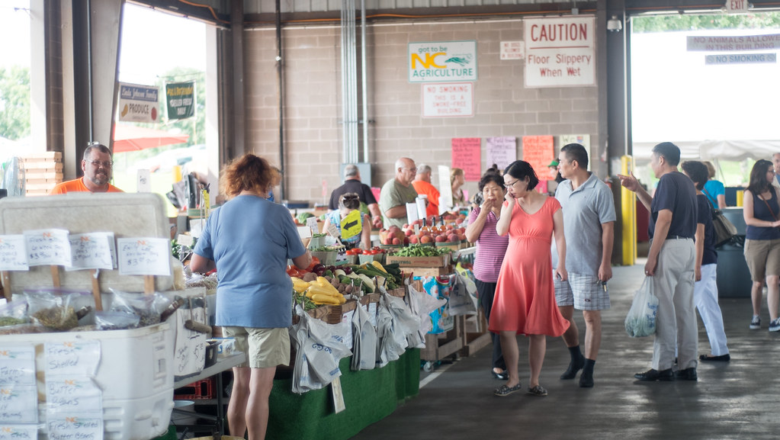
Sustainability in the Lowcountry:
Shopping Local, Fresh and In Season
By Meagan Young

W
hen Lauren Smith—an avid farmers market consumer—brings home fresh produce from her local farmers market. By doing so, she is leading a more sustainable lifestyle and benefiting the local economy.

Smith currently works within the sustainability office at Colorado University Boulder to promote healthier lifestyles to the students. This office is similar to the Office of Sustainability at College of Charleston.

The city of Charleston and the College of Charleston, both have sustainability plans implemented throughout the city. These plans are meant to educate and bring awareness to the effects of our actions on our environment. Through shopping at the farmers market and buying local products, many residents throughout the city can lead a green lifestyle.

The College of Charleston’s Quality Enhancement Plan (QEP) is intended to address the twenty-first century

Not only is Charleston known for delicious local produce, but also home to Sweetgrass baskets, https://ccsearch.creativecommons. org/ photos/689a50f8-f22e-4203-8682-1b4e9f88d619.

problems by familiarizing students with topics like climate change, social injustice, and equality. The focus of this plan is to spread sustainability literacy and by doing so the writers have created a detailed plan to teach college age students. The effects of this text have benefitted the College and the city in leading sustainable routines. Many classes also rely on this plan as a basis for their class, and in doing so students are encouraged to become knowledgeable about the subject.

“This is the best time of year to shop local,” Lauren said.

Consumers shopping in local farmers market, for their weekly produce, https://ccsearch.creativecommons.org/ photos/1b85563c-8d9a-42ea-9623-4123e699c5bd.

Charleston’s Green Plan, a roadmap to sustainability, is designed to show citizens how the city will create a more sustainable future for itself. Throughout the city, the Green Plan and all of its initiatives can be seen everywhere. From social media posts, to commercials, to signs and posters all over. Every post that is seen by residents has the ability to encourage people to look at the bigger picture, and change their actions.

Both of these programs focus on public health, sustainability, prosperity, and efficiency, and social injustices. Local and sustainable food production is one topic that everyone throughout the city can take part in: especially by purchasing items at farmers markets. Seeing an ad for the Marion Square Farmers market on social media, and following through by attending, is an easy step, that can lead to consumers to slowly transform their lifestyles.

“Boulder is very similar to Charleston. We have weekly farmers markets, and initiatives around the city and campus with the hopes to encourage everyone to shop local, not only to lead healthier lifestyles, but to have a lower carbon footprint, and support local businesses to stimulate the local economy.”

Every April, in the Lowcountry, the Marion Square Farmers Market opens with vendors, farmers stands, and food trucks from all around the city. During the peak growing season, these businesses source their produce, and ingredients locally and require less transportation which means that they are fresher. Consumers can shop knowing that their groceries are fresh, healthy, and much more of a reward than shopping conventionally.

Additionally, the West Ashley Farmers Market is available to locals on Wednesdays. The College also hosts a farmers market accessible to all students on Tuesdays on George Street. There are local initiatives throughout the entire city and college for locals to obtain sustainable products and lead sustainable lifestyles.

“Spreading awareness about the effects of shopping local is essential. Many consumers do not understand the difference between purchasing produce at a grocery store and from a local farmer,” Lauren said. “At CU Boulder, we like to host events and stay active on social media when it comes to sustainability and farmers market events.” Students and residents all over the city need to understand the effects of their actions.

The College of Charleston, similarly to Colorado University Boulder stay active on social media as well as hosting events and enhancement plans with the intention to get students to make a difference. Graduates and current college students have the ability to make a difference unlike any other generation. College students have the ability to communicate with one another, and bring awareness, they also have a huge value for a more sustainable environment than any other group of people.

“The best way to communicate with students and the younger generation about sustainability and our environment is through social media, and campus wide events,” Lauren said. Using social media to encourage consumers to lead more sustainable lives, is essential.

With farmers markets beginning to open, and Co-Ops starting, there is no better time to start having a better impact on our Earth. The Charleston Farmers Market, opening April 11 is the perfect way to start shopping local and sustainable, while also decreasing plastic usage and pollution, as well as getting an idea about where our food comes from. Staying active on social media and being informed on events around your city is equally important. Lauren in Colorado continues to post and spread ideas and events relating to sustainability, and shopping local especially during this time of the year.

