Small vs Large Influencers

Why Brands May Be Choosing Smaller Influencers Over Celebrities

By Christina Holt

Celebrities as well as normal people are becoming popular among brands’ chosen influencers. Influencers with smaller audiences are being chosen by brands to increase range and credibility of their audience. How do we know this, though?
For the past few years, influencers were considered social media figures who were already celebrities because they had large following. Brands chose these celebrities because they believed they were able to reach a high range in audience and sell more quantity than a simple blogger or someone with significantly less followers could. However, more recently, brands seem to be recruiting influencers without millions or even thousands of followers, but why?
In our society today an influencer is someone who has the ability to persuade potential buyers. Brands hire them to promote their products on social media. And such promotions often resemble personal recommendations. For instance, Khloe Kardashian promoting Fit Tea in an Instagram ad may resemble something I would post recommending a local boutique to my close friends and followers.
This idea that influencers persuade consumers to purchases the product came from the fact that each individual specializes in a specific thing. For example, if a personal trainer were to recommend a certain brand’s weights, consumers would be more likely to buy what they recommend because they have first-hand experience with the product. This specialty allows them to build authority and then buyers are more likely to buy what they recommend.
For example, consider Freestyle a company that makes and sells water resistant watches. Cameron Cassan, Freestyle’s sales representative, indicated that they work with influencers because “Our brand has always been a grassroots brand and most of our relevance has always been driven by local influencers since long before the days of social media. This is not a new approach for us, it is just leveraged through a new medium of communication.”
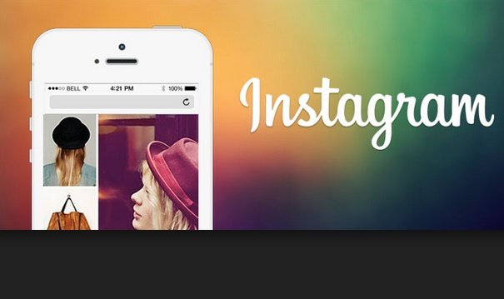
Freestyle, much like other brands, mainly uses Instagram to target their audience through influencers.
So, brands use influencer contracts through social media as a new form of communication, but how do they choose those influencers? Is it based on the audience numbers? According to Freestyle, “We use many [different influencers], but our primary focus is on our team athletes (surfers): Sage Erickson, Caroline Marks, Amber Torrealba and Luke Davis. And a variety of others in different regions and areas of influence.”
Here, it seems that Freestyle prioritizes the interests of followers or an influencer’s “area of influence.” The number of followers an influencer reaches is a less important concern but a concern, nevertheless. Casson continued to say that they contract influencers with large and small followings because “We feel like some have a macro audience that is more global in a sport or sector, but given our marketing approach and younger target audience, we also focus on developing a lot of brand ambassadors in all geographic and social areas of influence. We have over 7500 brand ambassadors in our ambassador program and they range from hundreds to millions of followers.” In other words, they strive for influencers with all different audiences to reach people from all over the world, not just a specific location, age or number.
They strive for influencers with all different audiences to reach people from all over the world, not just a specific location, age or number.

For Freestyle, they accumulate influencers from all audience ranges, but they seem to have more influencers that fall into the lower following category. Out of 7500 total brand ambassadors, they focus on a few select ones who surf and promote the product. For example, Sage Erickson who has 326K followers on Instagram. On the other hand, the other thousands of ambassadors have lower audience numbers. This may be due to credibility, awareness, branding and loyalty that normal people could give as opposed to celebrities.
It would make sense for less known influencers create credibility because brands would be less likely to reach out to them to promote their product just for the exposure on their media account. So, if a normal person advertised a product, it would be assumed that it wasn’t free or a paid advertisement. Selecting smaller influencers creates awareness by sharing their brand across many different audiences, not just those who follow celebrities. These influencers help their branding because if seemingly normal people bought their product then it must be genuine. This selection of influencers also creates loyalty by showing they support all their customers, not only ones with large following.
Brands can track their sales based on each influencer through ambassador programs, as Freestyle does. They see their influence and choose their ambassadors based on that sales data. Since they have thousands of smaller following ambassadors, then there must be success. What makes that so successful?
Smaller influencers might be more successful because of their genuineness. They’re more likely to seem genuine because brands wouldn’t just pay them to post a picture. When a promotional product post comes from a normal person, the buyer can relate to them and is more likely to buy a product by recommendation of a similar person.
I think that brands are choosing smaller influencers has become increasingly popular because of their ability to reach a wider audience. By contracting celebrities and normal people, brands have access to wider audiences due to the vast difference in follower count. They not only bring in new consumers that celebrities may not, but they also have a closer following relationship. Because we see celebrities post ads for the paid sponsorship or free products, we tend not to trust in what they post. However, with smaller influencers, it is different because they aren’t paid, they’re simply recommending a product they have to real people that follow them. Therefore, brands are choosing influencers with smaller following to access more people.

