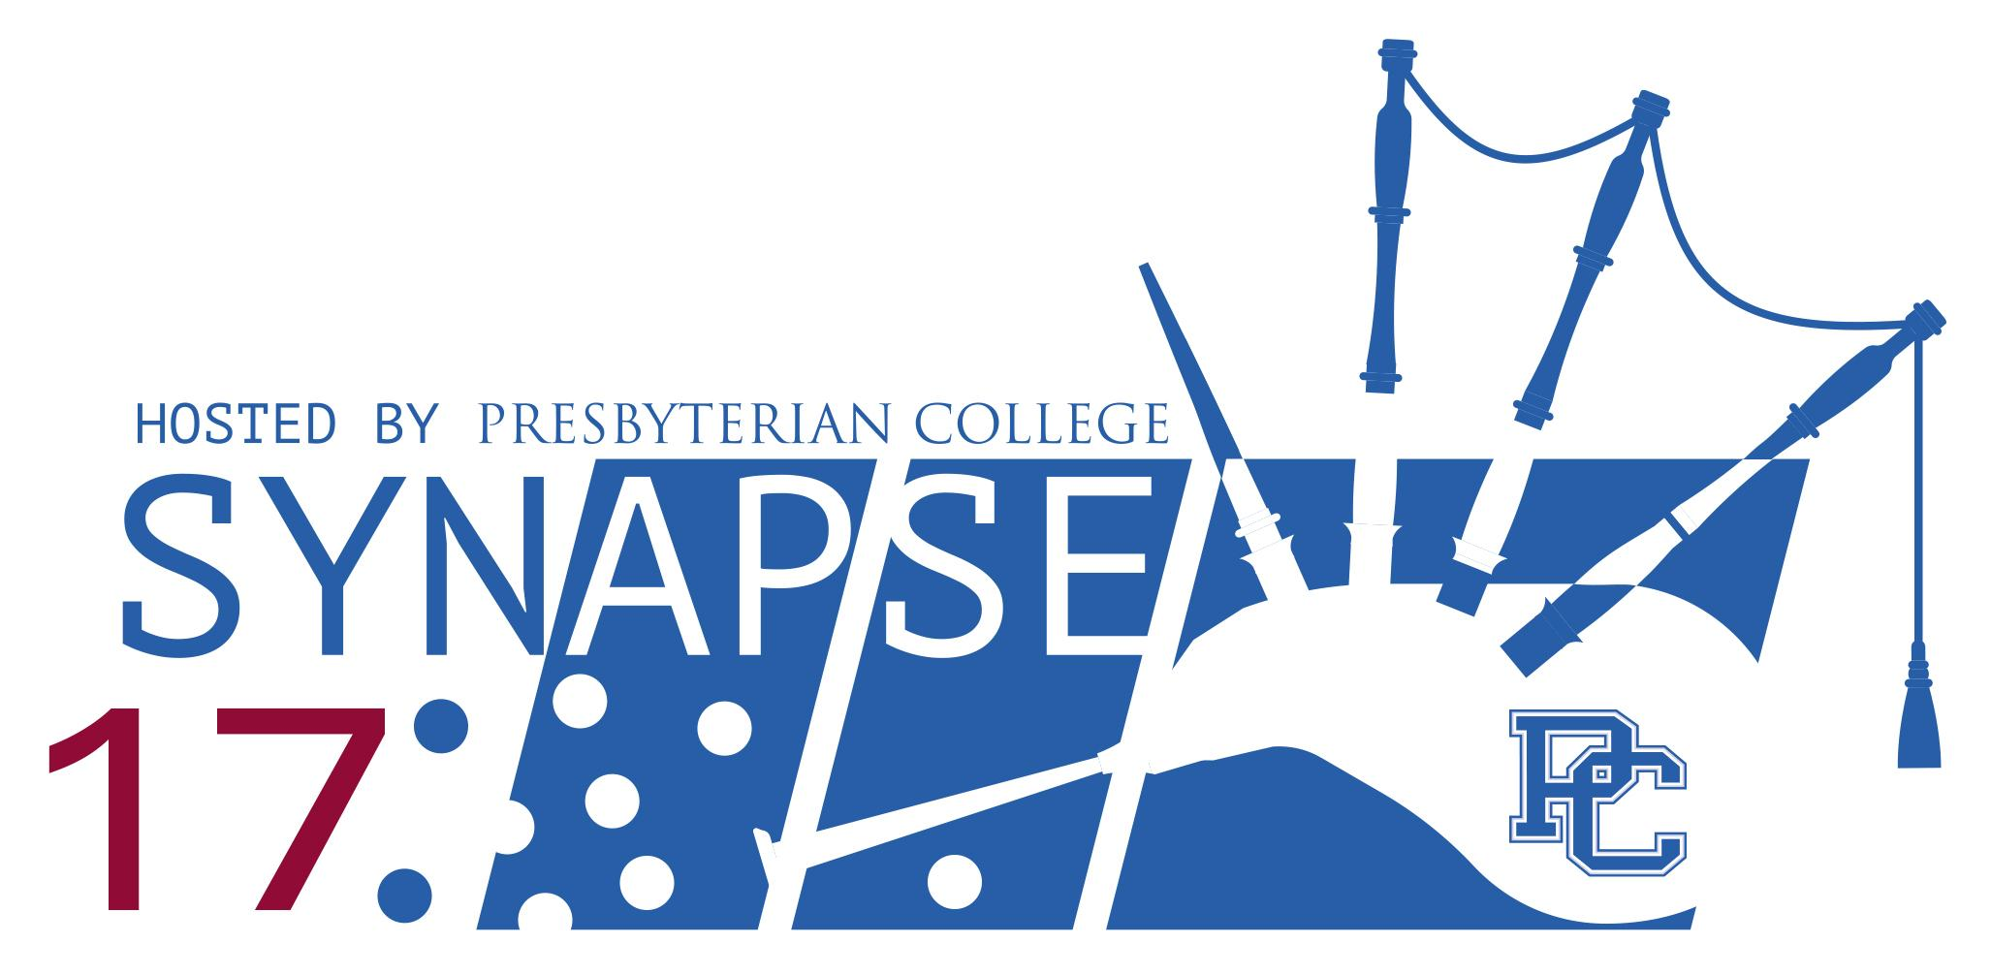

Symposium for Young Neuroscientists and Professors of the SouthEast
March 25, 2017

Presbyterian College
Clinton, South Carolina

SYNAPSE 2017

Saturday March 25, 2017
Presbyterian College, Clinton, SC

Location: Registration and Lectures: Edmund Hall

Posters and Workshops: Harrington-Peachtree Academic Center

7:30-8:25am Poster Set-up (Odd numbers only)
Location: Harrington-Peachtree Academic Center

7:30-8:25am Registration, Coffee & Light Breakfast
Location: Edmund Hall

8:30-9:45am Welcome & Opening Keynote Address
Location: Edmund Hall

Medicinal Cannabis: Science, Politics and Medicine

Mark Wallace, MD
Pain Management Specialist, Chair, Division of Pain Medicine, Department of Anesthesiology, University of California, San Diego, CA

Webpage:
https://healthsciences.ucsd.edu/som/anesthesia/research/faculty-research/Pages/wallace.aspx

9:45-10:30am Student Platform Presentations – Session I
Location: Edmund Hall

9:45-10:00am Effects of the CB1 neutral antagonist AM4113 on palatable food motivation
Awardee Speaker: Rose Ying
Department of Biology, Wake Forest University

10:00-10:15am Effects of epigenetic modifications in X-linked adrenoleukodystrophy
Awardee Speaker: Sarah Steadman
Department of Biology, Program of Neuroscience, College of Charleston; Department of Pediatrics, Medical University of South Carolina

10:15-10:30am The role of rostromedial tegmental nucleus afferents in suppression of reward seeking under punishment
Awardee Speaker: Samantha Black
Department of Biology, Program of Neuroscience, College of Charleston; Department of Neuroscience, Medical University of South Carolina

10:30-10:45am Coffee Break
Location: Harrington-Peachtree Academic Center

10:45-12:00pm Poster Session I (Odd numbers present)
Location: Harrington-Peachtree Academic Center
12:00-12:30pm Lunch pickup
Location: Harrington-Peachtree Academic Center

12:00-12:30pm Poster Session II Set-up (Even numbers only)
Location: Harrington-Peachtree Academic Center

12:30-1:00pm Lunchtime Workshop Session I

Location: Harrington-Peachtree Academic Center

Preparing for Graduate Study in Neuroscience
Keynote speakers: Dr. Mark Wallace and Dr. Axel Nimmerjahn
Location: Bennett A. Brown Conference Suite - Amphitheater

SYNAPSE Steering Committee Meeting
Location: Conference Room 204

1:00-1:30pm Lunchtime Workshop Session II
Location: Harrington-Peachtree Academic Center

Careers in Neuroscience
Dr. Adam Franssen, Associate Professor of Biology, Longwood University
Location: Bennett A. Brown Conference Suite - Amphitheater

1:30-2:45pm Poster Session II (Even numbers present)
Location: Harrington-Peachtree Academic Center

2:45-3:00pm Coffee Break
Location: Harrington-Peachtree Academic Center

3:15-3:45pm Student Platform Presentations – Session II
Location: Edmund Hall

3:15-3:30pm Regulation of behavioral flexibility by ventral hippocampus
Awardee Speaker: Kathleen Bryant
Department of Biology, Program in Neuroscience, College of Charleston; Department of Neuroscience, Medical University of South Carolina

3:30-3:45pm Mechanisms Underlying Cognitive Deficits Following Repeated Methamphetamine Use
Awardee Speaker: Jordan Costello
Department of Biology, Program of Neuroscience, College of Charleston; Department of Neurosciences, Medical University of South Carolina

3:45-4:45pm Closing Keynote Address
Location: Edmund Hall

How do glial cells control CNS function?
Axel Nimmerjahn, PhD
Assistant Professor
Waitt Advanced Biophotonics Center
Salk Institute for Biological Studies
La Jolla, San Diego, CA
Webpage:
https://www.salk.edu/scientist/axel-nimmerjahn

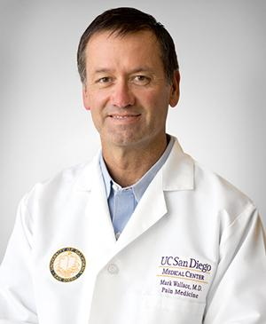

Medicinal Cannabis: Science, Politics and Medicine

Mark S. Wallace, M.D.
Pain Management Specialist
Chair of Division of Pain Medicine
Department of Anesthesiology
University of California
San Diego, CA

Mark Wallace, MD, is a board-certified anesthesiologist who specializes in multi-modal pain management. He has been the program director of UC San Diego Health’s Center for Pain Medicine since 1996. Under his leadership, the Center for Pain Medicine was named a Clinical Center of Excellence in Pain Management in 2010 and 2014 by the American Pain Society. Dr. Wallace is also chair of the Division of Pain Medicine within UC San Diego School of Medicine’s Department of Anesthesiology and has co-authored 119 peer-reviewed articles and five books on pain medicine. He is active in clinical trials of investigational drug and techniques for managing chronic pain. He received the Leonard Tow Humanism in Medicine Award in 2012 and is consistently elected as one of San Diego’s Top Doctors in San Diego Magazine's "Physicians of Exceptional Excellence" annual survey. Dr. Wallace is currently a member of the Board of Directors of the American Pain Society and serves on scientific planning meetings for both national and international meetings, including the World Congress of Pain, World Institute of Pain, American Academy of Pain Medicine and American Society of Regional Anesthesia and Pain Medicine.
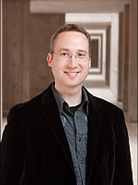
How do glial cells control CNS function?

Axel Nimmerjahn, Ph. D.
Assistant Professor
Watt Advanced Biophotonics Center. Salk Institute for Biological Studies
La Jolla, San Diego, CA

Axel Nimmerjahn, Ph.D., is an Assistant Professor with Waitt Advanced Biophotonics Center at Salk Institute. Dr. Nimmerjahn’s research focuses on elucidating the role of microglia - resident immune cells - and astroglia - key regulatory cells - in the healthy and diseased central nervous system through development of novel imaging tools and approaches. He has spearheaded the development of new microscopy techniques to visualize the dynamics of glial cells and their functional cellular interactions in the living CNS. He has also created new innovations for cell type-specific staining and genetic manipulation and for analysis of large-scale imaging data. This has improved the understanding of CNS function and how to treat neuroinflammatory and neurological disorders. He has been the recipient of many awards and honors including the NIH EUREKA Award, NIH Director’s New Innovator Award, Whitehall Foundation Award, Rita Allen Scholar Award, Human Frontiers Science Program (HFSP) Postdoctoral Fellowship, Du Bois-Reymond Award and Otto Hahn Medal and Award.

Poster Session Abstract Titles
(Listed Alphabetically by Author)

- AFFUL DK, SIEBELS AA, CHILDS AM, SCHMIDT JX,
ZEHER AM, CLELAND CL
Sensory Mechanisms Underlying the Escape Response to Looming Stimuli in Crickets
James Madison University

- ARJUNE K, BOLTON P, BRASINGTON A, BUNGE T,
PADULA S, PHILLIPS T, STEINMETZ KM
Examining Effect of Motivation, Arousal, and Valence on the N1: An event-related potential (ERP) study
Department of Psychology, Wofford College

- BLACK SL, LI H, JHOU TC, VENTO PJ
(Travel Award Winner)
The role of rostromedial tegmental nucleus afferents in suppression of reward seeking under punishment
Department of Biology, Program of Neuroscience, College of Charleston; Department of Neuroscience, Medical University of South Carolina

- BLUMENTHAL SA, PRATT WE
The Effects of Serotonergic Agonists on Mu-opioid Induced Feeding
Department of Psychology, Wake Forest University
- BRYANT KG, BARKER JM, CHANDLER LJ
(Travel Award Winner)
Regulation of behavioral flexibility by ventral hippocampus
Department of Biology, Program in Neuroscience, College of Charleston; Department of Neuroscience, Medical University of South Carolina

- COSTELLO JT, LAVIN A, PENA-BRAVO J
(Travel Award Winner)
Mechanisms Underlying Cognitive Deficits Following Repeated Methamphetamine Use
Department of Biology, Program of Neuroscience, College of Charleston; Department of Neurosciences, Medical University of South Carolina

- COWEN MH, LIZARRAGA SB
Understanding the Role of Rab3Gap1 in Neuronal Development
University of South Carolina

- DANIEL MA, QUINTERO G, GERHARDT G
Ganging Enzyme-Coated Microelectrode Sites Produces Greater Sensitivity to an Analyte in a Biosensor
University of Kentucky

- DEMARCO JD, JONE T, CONNER WE
Triggering jamming signals during the search and approach phase results in similar rates of capture in Eptesicus fuscus
Department of Biology, Wake Forest University

- DIXON K, ROTE A, FOO P
The Effect Of Soccer Related Concussions On The Emotional Health Of Student Athletes
Department of Health and Wellness and Department of Neuroscience, University of North Carolina at Asheville

- FRITH ME, LEUNG K, RAMIREZ JJ
Spatial Working Memory Performance on a Radial Arm Maze After Bilateral Fimbria-Fornix Transection in Rats
Department of Psychology, Davidson College

- GEIGER RE
Cognition Enhancement Using Transcranial Direct Stimulation (tDCS)
Tennessee State University

- HARILL SA, HARTMANN DA, NOONAN T, SHIH AY
Can Pericytes Regulate Blood Flow?
Department of Neuroscience, Medical University of South Carolina and Department of Biology, College of Charleston

- HOK E, GESLAIN R
Evaluating the neurotoxicity of unused transfer ribonucleic acids
Department of Biology, Neuroscience Program, College of Charleston

- ISHINO Y, SOSSI S, CUSTER S
Development of Molecular Tools to Study the Subcellular Synapse, Specificity of Cortical Interneuron Subtypes
Max Planck Florida Institute for Neuroscience

- JACKSON J, TURCHAN M, VAN WOUWE N
Action Control in Essential Tremor
Tennessee State University

- KREIBICH E, ASEMANI D, ROBERTS D
WinSCAT scores as a Reflection of Functional and Neurocognitive Changes Following Long-term Spaceflight
Department of Psychology and Program in Neuroscience, College of Charleston; Department of Radiology, Medical University of South Carolina

- LAHIRI S, BAKER CA, BOLTON MM
Dendritic Morphology in Mice with Defective Cleavage of the Autism Spectrum Disorder-Linked Protein Neuroligin-1
Disorders of a Neural Circuit Lab, Max Planck Florida Institute

- LEE DC, SHARKO AC, KAIGLER KF, FADEL JR, WILSON MA
Activation of Hypothalamic Orexin Neurons during Extinction of Fear Memories
Department of Physiology, Pharmacology, and Neuroscience, University of South Carolina - Columbia

- LEE DM, HYUN JH, JUNG K, HANNAN P, KWON HB
Calcium- and Light-gated switch of neuronal activity for gene expression
Department of Cellular Basis of Neural Circuit Plasticity

- LEROY V
Validation of siRNA against LPA receptor 4 to analyze retinal ganglion cell guidance
Winthrop University

- LONG ME, JONES GC, WARREN JW, MOTT DD
Cortical and Subcortical Projections to the Amygdala
School of Medicine, University of South Carolina

- MARINELLI NA, GAMZIS DE, DOUGLAS A, MCGUIRE A, COWEN MH, MORROW EM, LIZARRAGA SB
A human neuronal transcriptome study on and ASD environmental risk factor
Department of Biological Sciences, University of South Carolina

- MCDOUGLE MJ, GLOVER EJ, CHANDLER LJ
Effect of adolescent intermittent ethanol exposure on choline acetyltransferase expression
Department of Biology and Program in Neuroscience,
College of Charleston; Department of Neuroscience, Medical University of South Carolina
- MEDINA NIETO T, TRAWINSKI A, FAHRBACH SE
The effect of queen pheromone exposure on the growth of the worker honey bee brain
Department of Biology, Wake Forest University

- MURPHY AJ, SATTERFIELD R, YOUNG JR. SM
Development of a Helper-Dependent Adenoviral vector for the expression of Munc13 proteins
Research Group of Molecular Mechanisms of Synaptic Function, Max Planck Florida Institute for Neuroscience

- MURPHY JE, KIRKLAND A, YANES JA, KIRBY LAJ,
JANTZEN B, REID MA, ROBINSON JL
Left, right, or bilateral amygdala activation? How the effects of smoothing and motion correction on ultra-high field, high-resolution functional magnetic resonance imaging (fMRI) data alter inferences
Department of Psychology, Auburn University

- NOONAN TE, HARTMANN DA, HARRILL SA, SHIH AY
Optogentically Stimulated Pericytes have Transient Effects on Blood Flow
Department of Neuroscience, MUSC and College of Charleston

- PATEL NV, HUGHES M
Neuroplasticity and behavioral consistency related to trauma and recovery in snapping shrimp
Department of Biology, Program in Neuroscience, College of Charleston

- PATINO EM, ROWAN MJ, CHRISTIE JM
Activity-Dependent Labeling of Cerebellar Interneurons during Motor Learning
Max Planck Florida Institute for Neuroscience; Department of Biology, Florida Atlantic University

- PEGELOW ME, MAVI S, GRIGORYAN DA, CLELAND CL
What is the Nociceptive Withdrawal Response of Unrestrained Rats when Noxious Stimulation is Delivered to the Tail or Feet?
James Madison University

- PEL AV, LOM BM
Ethanol Compromises Xenopus laevis Development
Department of Biology, Davidson College

- PINEDA G, GHATE P, LIZARRAGA SB
Modeling gene-environment interaction in autism spectrum disorders with stem cell technology
Department of Biological Sciences, University of South Carolina

- RATLIFF KE, FRANSSEN CL, EAGLE AK, ZIMMERMAN CA
Working in Nature: Behavioral Neuroendocrinological Measures of Stress and Well-Being in Yellowstone National Park
Longwood University

- REED E, SILVER WL
The Search for Chemoreceptors in the Earthworm (Eisenia hortensis)
Department of Biology, Wake Forest University

- ROBBINS I, ANDERSON RI, BECKER HC, LOPEZ MF
Habitual Responding for Alcohol in C57BL/6 Mice
Department of Biology and Program in Neuroscience, College of Charleston; Addiction Sciences Division, Department of Psychiatry, Medical University of South Carolina

- ROSALES RIVAS J, MANNS P, ENRIQUEZ C, LOM B
BPA and BPS do not affect tyrosine hydroxylase or swimming activity in Xenopus laevis tadpoles
Davidson College

- RYAN C, HIDALGO-LOPEZ M, SCHUMMERS J
Astrocyte morphology shaped by placement within functional maps in ferret visual cortex
Florida Atlantic University, Max Planck Florida Institute for Neuroscience

- SAMMONS KM, DEAK LC, CLELAND CL
Selective Stimulation of A-delta Nociceptors in Rat Hind Limb and the Resulting the Nociceptive Withdrawal Response
James Madison University

- SHANKS MK, OPRISAN SA
Functional near-infrared spectroscopy (fNIRS) while performing temporal discrimination tasks
Department of Biology, Department of Physics and Astronomy, Program in Neuroscience, College of Charleston

- SLEDGE RA, MOORE EJ, JOHNSON HL, KAPLAN ZS,
SNOUSE SJ, PAVELKA MN, EVERETT SK, FENNELL CT, ZRULL MC
The IMPULSE journal: a practical teaching tool for a neuroscience minor
The Honors College and Department of Psychology, Appalachian State University

- STEADMAN S, BAARINE M, SINGH I
(Travel Award Winner)
Effects of epigenetic modifications in X- linked adrenoleukodystrophy
Department of Biology, Program of Neuroscience, College of Charleston; Department of Pediatrics, Medical University of South Carolina

- UNROE KA, FRUCHTERMAN TC, RIPLEY AO, FRANSSEN RA
Estrogen Receptor Levels Higher in "Bad" Maternal Rats than in "Good" Maternal Rats
Department of Biological and Environmental Sciences, Longwood University
- VALIULIS GJ, WEBER RA, ADKINS DL
Pharmacological Enhancement of Rehabilitation After Ischemic Stroke in Rats
Department of Biology and Program in Neuroscience, College of Charleston; Department of Neurosciences and Health Science Research, Medical University of South Carolina

- WANLISS JA, LIU D, BROWN D, WASHINGTON B
Human Psychomotor Skills Acquisition
Presbyterian College

- YING R, PRATT WE
(Travel Award Winner)
Effect of the CB1 neutral antagonist AM4113 on palatable food motivation
Department of Biology, Wake Forest University

