Fall ’16: RELS 298/ENVT 352
“The Spirit of Sustainability”
MWF 11:00-11:50am ECTR 103
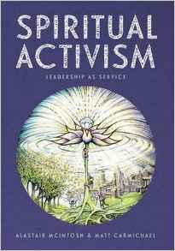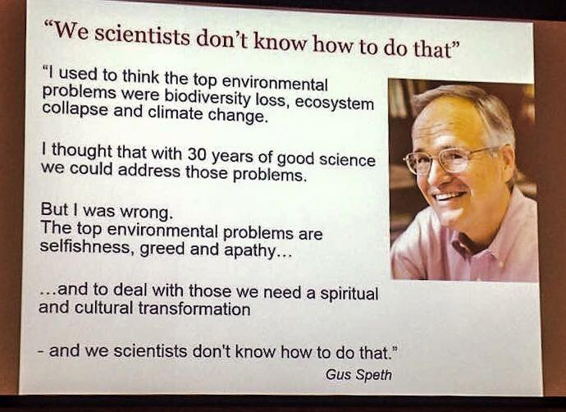

This course examines sustainability from the context of religious ethics and spiritual activism. It explores the current ecocrisis, its sources and the social and environmental impacts of the ecocrisis, and then analyzes various responses from religious institutions and spiritual leaders to the ecocrisis. Attention will be paid to how religious and spiritual visionaries and leaders are advocating for structural and behavioral changes, couched in the language of religious ethics and inter-species justice, geared towards generating resilient, sustainable communities of place. Classes will be a mix of lectures, videos, and group discussion, with possible field trips and guest lectures from local sustainability activists.

