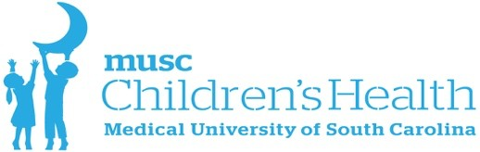
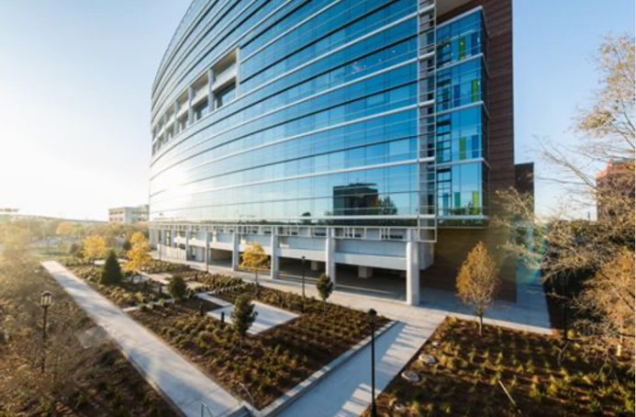
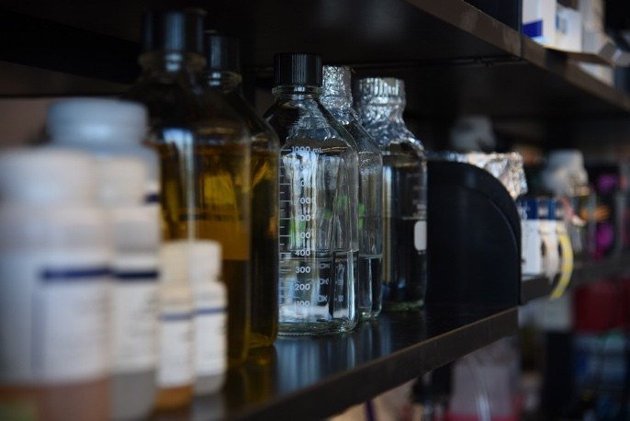
The John Covington and Robert Lukey Summer Scholarship in the MUSC Darby Children’s Research Institute

PURPOSE
The purpose of The John Covington and Robert Lukey Scholarship is to provide an opportunity for undergraduate students to perform pediatric clinical and basic science research.

OVERVIEW
The Darby Children's Research Institute (DCRI) is the research arm of the Department of Pediatrics and the Shawn Jenkins Children’s Hospital at the Medical University of South Carolina (MUSC). The DCRI is comprised of basic and physician scientists working together with a common goal to perform impactful science that can be translated for the wellness of children’s health. The DCRI is composed of state-of-the-art laboratories with faculty, post-doctoral researchers, and graduate students spanning multiple disciplines in childhood health and disease.

The primary objective of The John Covington and Robert Lukey Scholarship is to provide funding for undergraduate students with strong interests to gain exposure to a clinical and basic science pediatric research experience in a nationally ranked academic medical center that will advance their career aspirations.

Information on the DCRI and areas of research can be found at the following link: https://dcri.musc.edu

ELIGIBILITY
- Must be enrolled in an undergraduate accredited US college or university institution.
- Must be able to physically work in a designated lab for an 8-week program.

KEY DATES
- Applications due: March 1, 2024 at 5:00 pm EST
- Applicants will be notified of awards: March 15, 2024
- Award Period: June 1, 2024 - July 31, 2024

AWARD AMOUNT
$4,000 stipend for the student fellow / $1,000 for consumable lab supplies

APPLICATION FORM AND DOCUMENTS
Document
- Font Type and Size Arial, 11pt.
- Page Margins No less than 0.5” on all sides
- Document Type single PDF file

Required Documents/Files
- Cover letter – Include what peeks your interests in pediatric research either basic or clinical. Do you have a particular area of interest? Are you interested in a particular DCRI researcher from the information provided on the DCRI website or publications? (1 page)
- Personal and Scientific Background (1-2 pages) – Please describe your educational background in science, why you would like to take advantage of this opportunity, and how this would enhance or further your career goals?
- Resume or CV
- Letter of Recommendation (1 letter minimum)
SUBMISSION PROCESS
- Combine all documents into a single PDF file
- Email to Jasmine Ballentine (ballentj@musc.edu), Subject Line: DCRI Summer Fellowship Program

QUESTIONS
Please address questions to Jasmine Ballentine at ballentj@musc.edu

