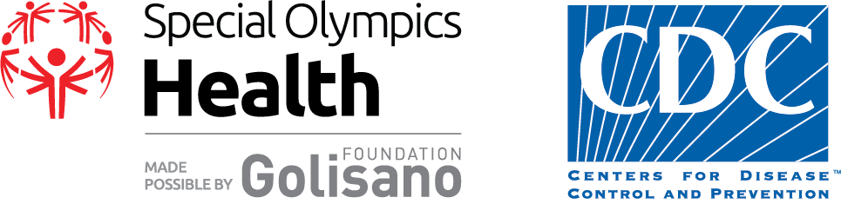

Volunteers Needed
Special Olympics South Carolina Health Fair
March 6, 2020 - 7:30 a.m. - 3:00 p.m.
Charleston Convention Center

Special Olympics South Carolina focuses on building sports opportunities, education programs and increasing health screenings for individuals with intellectual disabilities. For the first time, SOSC is partnering with MUSC to bring
Healthy Athlete screenings to local schools.
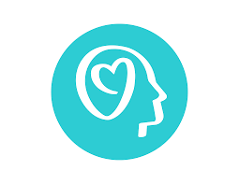
Healthy Hearing (Audiology) Strong Minds (Adaptive Coping Skills)
Special Smiles (Dentistry) Fit Feet (Podiatry)
Health Promotion (Nutrition Education)

All volunteers must attend an in-person training with SOSC Clinical Directors.
Training will be held in February 2020.

Register to Volunteer
Kara Harmon
kharmon@so-sc.org

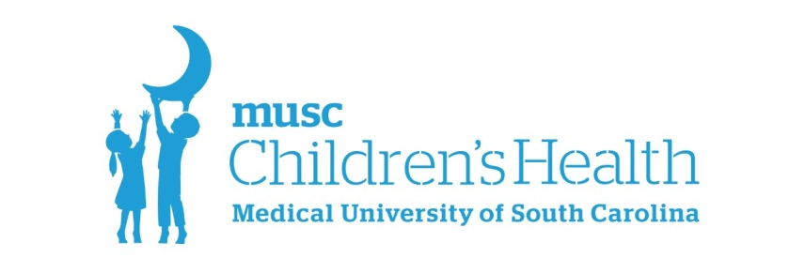

What is Developmental-Behavioral Pediatrics (DBP)?
DBP encompasses the evaluation and care of children and adolescents with developmental disabilities (such as Down syndrome, autism spectrum disorder, cerebral palsy, spina bifida, intellectual disability), developmental delay, learning disabilities, ADHD, and behavioral disorders.

Multidisciplinary Care: Who do we work with?
We enjoy collaborating with other health care professionals such as general pediatricians, nurses, psychologists, psychiatrists, speech and language pathologists, physical therapists, occupational therapists, and social workers in efforts to provide comprehensive care for children with special needs.

Why should I volunteer?
Events such as the Special Olympics Health Fair help facilitate the multidisciplinary care that benefits patients. They can also be valuable networking events for providers, in which we all learn about other disciplines and how to best care for individuals with special needs.

