Research Opportunity at MUSC
Undergraduate volunteer research opportunity in cardiovascular developmental biology
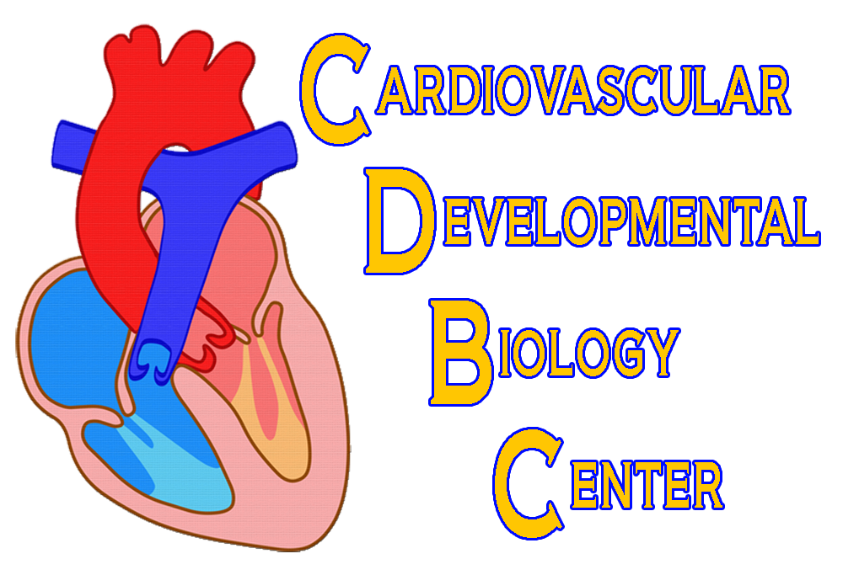
Preferably sophomores interested in research opportunities for the independent study and/or Bachelor’s Essay.
Pleased send resume to sugiy@musc.edu. Please indicate your GPA.
Yukiko Sugi, Ph.D
Associate Professor
Regenerative Medicine and Cell Biology
Cardiovascular Developmental Biology Center, MUSC
e-mail: sugiy@musc.edu
web: http://regmed.musc.edu/Faculty/SugiY.htm

Learn More
Current Research Focus for Volunteer Student Researchers
- Study the role of BMP signaling in cardiovascular development using genetically engineered mouse models.

Key Words: Cardiovascular Development, BMP signaling, Endocardial Cushions, Cell Lineage Determination, Congenital Heart Defects (CHDs). Genetically Engineered Mouse Model, Primary Cell Culture.

Approach: DNA extraction and PCR (genotyping). RNA extraction and quantitative RT-PCR. Histology. Immunohistochemistry. Amira 3D Reconstruction. Microscopy.

*** Please visit web: http://regmed.musc.edu/Faculty/SugiY.htm and send resume to sugiy@musc.edu . Please include your GPA.

