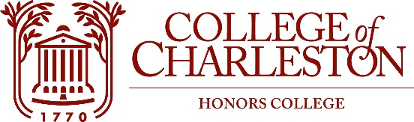

Content and Community Manager Intern

Overall Job Description: The Content and Community Manager plays an essential role in maintaining the Honors Hub and sustaining engagement across all Honors College social platforms. Under the supervision of the Director of Marketing and Admissions, the intern will coordinate, edit, and produce content in various forms, and will be the “voice” of the Honors College on all outlets. This position is ideally suited for students who hope to gain experience in the fields of leadership, journalism, higher education, social media marketing and/or content creation. This position reports to the Director of Marketing and Admissions and will also interact frequently with the Associate Director of Admissions, other student interns, as well as the Honors Student Ambassadors.

Responsibilities:
- Create content and maintain the following platforms: the Honors Hub, 10 Green Way, Instagram, Twitter, and Facebook
- Implement a communications calendar for all social media outlets and Honors College blogs
- Engage with followers on various platforms in a timely fashion
- Copyedit and proof an array of content
- Monitor trends in social media channels, tools and applications, and apply that knowledge to increasing the use of social media in the Honors College.
- Design promotional materials for a variety of Honors events and initiatives in line with the CofC Brand Manual
- Other duties as assigned

Qualifications: Students of all majors are encouraged to apply. Strong interest in working with social media and content marketing in a professional atmosphere. Multi-tasker with initiative to self-motivate and complete tasks. Knowledge of social media platforms, design platforms (e.g. Canva) and basic knowledge of WordPress preferred.
Work Schedule and Compensation: Work available at up to 10 hours per week, with the option of a flexible schedule. Pay starts at $10/hour.

