What is intersectionality, and what does it have to do with me?

Intersectionality, n.: The interconnected nature of social categorizations such as race, class, and gender, regarded as creating overlapping and interdependent systems of discrimination or disadvantage; a theoretical approach based on such a premise. (Oxford Dictionary)
Intersectionality is a framework for conceptualizing a person, group of people, or social problem as affected by a number of discriminations and disadvantages. It takes into account people’s overlapping identities and experiences in order to understand the complexity of prejudices they face.
In other words, intersectional theory asserts that people are often disadvantaged by multiple sources of oppression: their race, class, gender identity, sexual orientation, religion, and other identity markers. Intersectionality recognizes that identity markers (e.g. “female” and “black”) do not exist independently of each other, and that each informs the others, often creating a complex convergence of oppression. For instance, a black man and a white woman make $0.74 and $0.78 to a white man’s dollar, respectively. Black women, faced with multiple forms of oppression, only make $0.64. Understanding intersectionality is essential to combatting the interwoven prejudices people face in their daily lives.
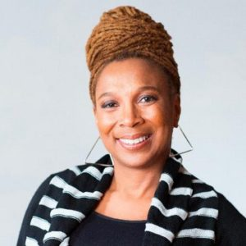
Kimberlé Crenshaw, law professor and social theorist, first coined the term intersectionality in her 1989 paper “Demarginalizing The Intersection Of Race And Sex: A Black Feminist Critique Of Antidiscrimination Doctrine, Feminist Theory And Antiracist Politics.” The theory emerged two decades earlier, however, when black feminists began to speak out about the white, middle-class nature of the mainstream feminist movement. Many black women found it difficult to identify with the issues of the mainstream (white) feminist movement, issues such as the pressure to be a homemaker. Black women, who often had to work in order to keep their family afloat and therefore did not have the luxury of being homemakers, did not feel as though these issues pertained to their experiences. At the same time, many black women experienced sexism while participating in the Civil Rights movement and were often shut out of leadership positions. This intersectional experience of facing racism in the feminist movement and sexism in civil rights encouraged black women to call for a feminist practice that centralized their lived experiences. (TED talk by Kimberlé Crenshaw)
The Combahee River Collective, a black feminist lesbian organization, released the Combahee River Collective Statement in 1978 to define and encourage black feminism. In the introduction these women state that “The synthesis of these oppressions creates the conditions of our lives. As Black women we see Black feminism as the logical political movement to combat the manifold and simultaneous oppressions that all women of color face.” They fought not only for representation in both the Civil Rights and feminist movements, but also for recognition as black women, rather than just black or just female individuals.
Crenshaw expanded on the Collective’s theory, stating that in order to understand the oppression of black women, it is necessary to look at the intersection of blackness and womanhood. While many who championed intersectionality early on were African American women, the theory has proven necessary to understanding a wide range of difference, including individuals’ sexual orientation, age, class, disability, and more.
Nowadays, intersectionality is considered crucial to social equity work. Activists and community organizations are calling for and participating in more dynamic conversations about the differences in experience among people with different overlapping identities. Without an intersectional lens, events and movements that aim to address injustice towards one group may end up perpetuating systems of inequities towards other groups. Intersectionality fully informs YW Boston’s work, by encouraging nuanced conversations around inequity in Boston. It enlightens us to health disparities among women of color, provides pathways for our youth leaders to understand identity, and is crucial to the advocacy work we support.

What can I do?
Intersectionality may seem theoretical, but it is meant to be utilized. No matter how or when you have become involved with equity work, it is always possible to more fully integrate intersectionality into your view of these issues. Is your work toward social equity intersectional? Check out these tips and reflect:
- Recognize difference.
Oftentimes, it is easier to believe and to explain to others that “all women feel” a certain way or that “LGBTQ+ people believe” some common understanding, but this does not reflect reality. We must recognize that all unique experiences of identity, and particularly ones that involve multiple overlapping oppressions, are valid. Do not shy away from recognizing that people experience the world differently based on their overlapping identity markers. Because of the way we have been socialized to continue feeding systems of oppression, we often feel it is rude to formally recognize others’ difference. We see this in how people are uncomfortable naming another person’s perceived race or asking for someone’s preferred pronouns. However, we must recognize these identities as a way to step beyond our assumptions that our experience is common. One way of doing so is when you attend rallies, take a look at the signs that others hold — how do they assert their identity and how does this inform the issues they care most about?
- Avoid oversimplified language.
Once we recognize this difference, we can move away from language that seeks to define people by a singular identity. You may have heard after the Women’s March that many trans folks and allies felt uncomfortable with the vagina-centric themes of the march. Assuming that all women have vaginas or are defined by their bodies is an oversimplification that erases the experiences of those who exist beyond the gender binary. By avoiding language that assumes our own experiences are baseline, we can open ourselves up to listening to others’ points of view.
- Analyze the space you occupy.
Becoming comfortable recognizing difference also involves recognizing when that difference is not represented in the spaces you occupy. Diversity of all kinds matter in your workplace, your activism, your community spaces, and more. If you are meeting with a local LGBTQ+ organization, is there representation of LGBTQ+ people of color? You may feel that your workplace is racially and ethnically diverse, but is it accessible to people with disabilities? Take note of the welcoming or distancing practices of the spaces you frequent.
- Seek other points of view.
Explore the narratives of those with different interlocking identities than you. This includes surrounding yourself with others with differing interwoven identities, but keep in mind that oftentimes, even when you have a diverse group of people in an activist space, it falls on people to educate others about the oppressions they face. When these people share their experiences, take the opportunity to listen. However, do not expect people with identity markers other than your own to be there or to want to educate others. In your own time, seek out existing intersectional narratives, from your podcasts to your television. If you are unsure about a concept or want to learn more about a specific intersection of identity, Google it! This will help you be better prepared to enter into conversations with others and progress together.
- Show up.
Do not expect people who face different systems of oppression than you to rally for causes you care about if you do not rally for theirs. As you hear about issues others face, learn about the work that is currently being done around these topics. Listen and defer to those who live with these intersectional identities each day. As you do, you will likely deepen your understanding of your own identity and the subjects you care about most.
Downloaded from: https://www.ywboston.org/2017/03/what-is-intersectionality-and-what-does-it-have-to-do-with-me
Intersecting Axes of Privilege, Domination, and Oppression
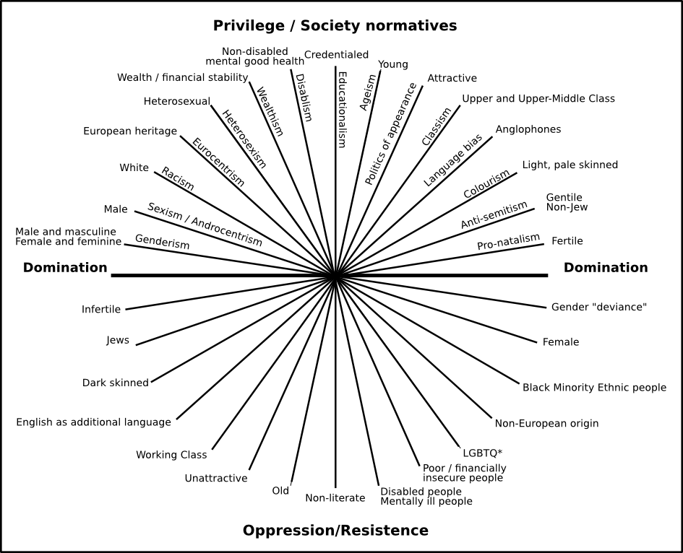
Downloaded from: https://ncda.org/aws/NCDA/pt/sd/news_article/139052/_PARENT/OLDER_layout_details/false

