Lesson Title | The US enters War | Teacher | Leah Spann
Grade Level | 5th Grade | Duration of Lesson | 1-2 classes
Lesson Topic | United States enters World War I
SC Standards and Indicators | Standard 5-3 The Student will demonstrate an understanding major domestic and foreign developments that contributed to the United States becoming a World Power.  Indicator: 5-3.6 Summarize the factors that led to the involvement of the United States in World War I and the role of the United States in fighting the war.
Common Core Strategy(ies) addressed | Key Ideas and Details -5th Grade  #2: Determine the central ideas or information of a  primary or secondary source; provide an accurate  summary of the source distinct from prior  knowledge or opinions.
Academic Vocabulary | Propaganda , neutrality, yellow journalism, Zimmerman telegraph, doughboys,Trench warfare, Central powers, Allies Power, Woodrow Wilson’s 14 points, Treaty of Versailles, League of Nations, Neutrality Acts
Lesson Materials | Smart board lesson, Social Studies partial notes, Rubric for yellow journalism
Content Narrative  (What is the background information that needs to be taught to understand the context of the lesson? Be sure to include necessary citations) | The United States tried to stay out of World War I. As hard as they tried, the US entered on the side of their allies, Britain, France, and Russia to fight in World War I. On April 6, 1917 the United States enters World War I. Many Americans wanted to remain neutral.  World War I started because of disagreements in Europe over boundaries and territories among some of the countries. Then Archduke Ferdinand of Austria was assassinated by a Serbian nationalist. Austria Hungry then declares war on Serbia. Russia enters the war to protect its trade route on the black seas and decides to enter the war to help Serbia. Germany enters the war and becomes an Allied with Austria-Hungary. Germany basically tell Russia dismiss its army. They refused and Germany declares war on Russia. Germany was afraid that they would have to fight in two different places because Russia was to their east and France was to their west. France is an ally to France. So Germany declares war against France. Soon every European country was involved in the war.  The fighting did not seem as though it would not cease. The United States was practicing a policy of isolationism, meaning they wanted to remain out of the war. In 1915, a German Submarine torpedoed and sank a British steamship named the Lusitania. On the Lusitania there were more than 100 US citizens. This heightens the tensions in the United States. Some Americans felt that we should go to war. Woodrow Wilson wrote a letter to Germany stating that the US objected to attacks on non-military ships. Then Germany sent a letter to Mexico asking them to enter on the side of the Central powers. They promised Mexico they would help them get their land that they lost back. The United States intercepted this letter. The last straw for the US is when Germany attacks ships that are carrying supplies to the Allied Powers. They sunk three of these ships and killed American sailors. This angered US and the US enters the World War I.  Scott Foresman. Growth of a Nation
Lesson Set
Content Objective(s) | The student will analyze a primary source document and discuss  Questions with a partner. Students will also illustrate their own yellow  Journalism of the War.
Literacy Objective(s) | Compare the locations of places, the conditions at places, and the connections between places.
Lesson Importance | The lesson helps students to understand the role that the United States took in entering World War I.
Connections to prior and future learning | The United States will try and remain Neutral once more but circumstances beyond our control will cause the United States to enter another war again.
Anticipatory Set/ Hook (Engage) | Ask students how do they feel about war? Have students recall the Civil war and how it was a deadly war that left lots of bloodshed and destruction in its path. Have students write a journal entry about how they would feel if the US got involved in the war? How would it affect the people of our country?  Have students share their thoughts with a partner and then share with a group.  Hook included on SMART Board Lesson.

Skill Development
Initial “explain” portion of the lesson. Introduce vocabulary, explain/demonstrate/model the skill required for the literacy objective, introduce content components.
The content portion is only a brief introduction; the bulk of the student learning will take place during the guided practice activity.
Introduce content components | Teacher will introduce vocabulary Words to students. (Smart board Lesson)  Note: Teacher can have students copy words and vocabulary from the board. Discuss with students what each term means prior to the lesson or as each term comes up in the lesson. Vocabulary words will be highlighted.
“I do”  Skill from objective  introduce/explain/model | Teacher will go over the lesson with students in whole group. Students will as they go along fill in a cloze procedure about the Smart board lesson. Students should pay attention and fill in as teacher goes along.  (Cloze worksheet is located at the end of this lesson. )

Guided Practice
This is the inquiry portion of the lesson, student-centered & often cooperative learning strategies used, teacher acting as facilitator, also known as Explore.
“We do”  Activity Description  Include student “explore” components and opportunities for them to explain their learning. | Teacher and students will go through the smart board lesson together. As students and teacher go through the smart board students will fill in the Cloze procedures as teacher goes along with the smart board.  Then teacher will show students the primary source document that is located on the end of the smart board lesson. Students will answer the questions with a partner. Teacher can print a copy so that each group can have a copy of the questions. As students answer the questions teacher will observe and make sure students are working with their partners.
Checking for Understanding-“Informal” Assessment | Teacher will ask students questions: What made the United States enter World War I? Where we right in entering the war? How do you feel about the Wilson’s fourteen points? Did it really mean we won’t be at war again?  Student’s answers may vary on this.

Closure
Teacher will re-visit content and answer students’ questions developed during the Guided Practice component. Summarize the lesson, clarify content, and revisit content and common core strategies.
Content Solidified | Teacher will have students take a short assessment. Teachers can use the smart response or students can use a wipe off board to answer these questions. ( The Questions are located on the bottom of Smart board lesson.  - Who were the central Powers? Austria, Hungary, Ottoman Empire, and Germany  - Who was president during World War I? President Woodrow Wilson  - What was the Zimmerman telegram? It was a telegram from Germany asking Mexico to attack America.  - What was the name of the treaty that included the League of Nations? Treaty of Versailles  - What was the treaty based off of? Wilson’s 14 points

Independent Practice
“You Do” | Students will complete their own piece of Yellow Journalism about World War Teacher will show students examples of Yellow Journalism. (http://academic2.american.edu/~wjc/yellowjo/photo5.html Teacher will express to students how Yellow Journalism blew things out of proportion. Teacher will ask students what do headlines do and how do they appeal to our emotions. Then students will work in groups and come up with a headline and make it Yellow and about World War I. Students will then write a short paragraph explaining in their own words how the United States became involved in the war. Teacher will use the rubric attached at the end of this lesson to asset students on their Yellow Journalism project.

Summative/ “Formal” Assessment
Assessment | Students will put the following events about World War I into chronological order.  - Zimmerman telegraph is sent to Mexico from Germany.(3)  - The treaty of Versailles is signed.(6)  - The United States enters the World War I. (5)  - The Lusitania was sunk and killed some Americans.(4)  - The United States decides to remain neutral. (2)  - Tensions in Europe lead to countries invading each other. (1)
Differentiation
During Lesson | Students will be allowed to choose their partners. Students will work with partners to make sure that they have their notes.
Assessment | During assessment students will use the smart response remotes to take their test. Also during informal assessments, teacher will make sure that students are participating in the projects.
Reflection
Lesson Reflection  (What went well in the lesson? What might you do differently the next time you teach it? Evaluate the success of the lesson) | The lesson went well. I did have to re-teach yellow journalism more to make sure students understood the project that was expected of them. Students were very engaged and pay close attention to the smart board lesson. Also students had some difficulty working with each other on their Yellow Journalism project. Next time I will already pair students up with a partner. The students loved using the Smart response system on smart notebook to take their assessment. It was a very easy way to access what students knew from the lesson. Overall, I believe this worked well with my students.

Materials
Lesson Materials | Social Studies Notes are attached to the lesson plan. Rubric is attached at the end of this lesson plan. Smart board lesson is attached.

WWI: Why America joined the war
- America became involved in World War I for multiple reasons.
  - Wartime Propaganda , sympathy, and our ___________ with _________ ____________
  - Belief of ______________ __________________.
  - The _______________ was sunk by the German ________________.
  - The interception of the ____________ _________________.
- Germany told America and other countries that no _______ were allowed to travel to ________ or ___________. , However, Americans believed in _____________ ______________. Thus, we thought no one should be allowed to tell us where we could or couldn’t go.
- The ________________ was an American ship that was out to _________. It was carrying mostly ____________. Germany thought that it was carrying ____________ and ______________ for Britain. Therefore, the Germans sent out the U- __________, which was a submarine and they sent a ____________ after it. This ended up sinking and destroying the Lusitania.
- The ________________ ___________________ was sent to ________________ from ____________. It offered Mexico the land America took from them during the _____________ Cessation if Mexico went to war with the _____________. It was intercepted and reported back to America.
- ________________ ________________ began to ___________ articles supporting the war.
- President _________ ________________ asked ______________ to declare war to make the world safe for ________________.

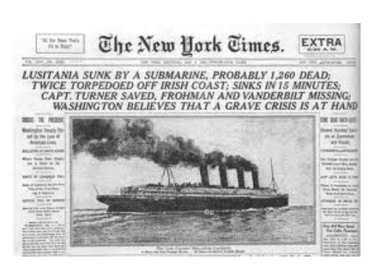

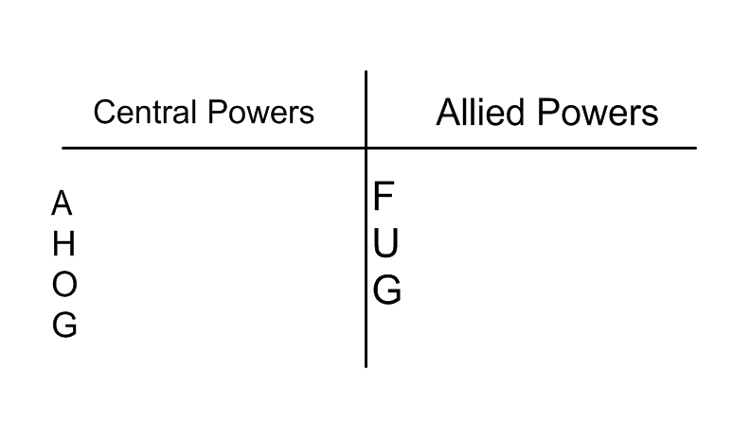

- There were ____________ sides to the war. The ______________ Powers and the ___________ Powers.
- The central Powers ultimately agreed to stop ____________ in order to have peace negotiations. However, they had to be based on ____________ Wilson’s ______ points.
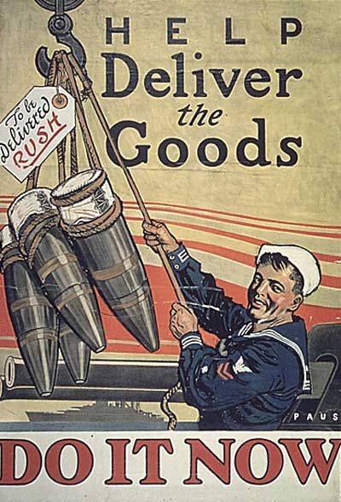
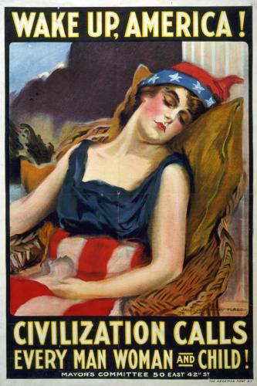
- Some of the major points of Wilson’s 14 points were: ___________ state borders in ____________ to better reflect nations, groups of people with the same ____________, religion and _________ heritage.
- This lead to the _ ______________ of Versailles.

Yellow Journalism Project Rubric
Name: ______________________________
Date: _______________
Class: ________________________________________
 | Exemplary | Effective | Unsatisfactory
SUBSTANTIVE
• Headline | Catching headline. Creative and pertains to World War I  Paragraph is well written contains little errors. | Good headline that pertains to World War I. Paragraph is well written and contains very little errors. | Headline is not catching and does not pertain to anything about World War I. Paragraph is not well written and has lots of errors.
• Effort put forth | Works diligently and without prompting | Works diligently, after prompting | Does little or no work, even with prompting
• Overall quality of work | Quality of work is to the students best ability | Good work, but not up to students standards | Poor presentation, clearly not the student’s best work.
COMMENTS:

