Lesson Title | The New Deal | Teacher | Bruce Bradley
Grade Level | 11 | Duration of Lesson | 90-180 Minutes
Lesson Topic | The New Deal
SC Standards and Indicators | USHC-6.4 Analyze President Franklin Roosevelt’s New Deal as a response to the economic crisis of the Great Depression, including the effectiveness of New Deal programs in relieving suffering and achieving economic recovery, in protecting the rights of women and minorities, and in making significant reforms to protect the economy such as Social Security and labor laws.
Common Core Strategy(ies) addressed | Determine the central ideas or information of a primary or secondary source provide an accurate summary that makes clear the relationships among the key details and ideas.  Integrate and evaluate multiple sources of information presented in diverse formats and media.
Academic Vocabulary | New Deal, Socialism, FDIC, AAA, TVA, WPA, Franklin Delano Roosevelt, Relief, Recovery, Reform
Lesson Materials Needed (attached at end of lesson) | Attached documents and QR codes, iPad or smart phone with QR code reader app (such as Red Laser), projector.
Content Narrative  (What is the background information that needs to be taught to understand the context of the lesson? Be sure to include necessary citations) | This lesson can occur in the middle of the New Deal part of the Great Depression unit. Students should already have a basic knowledge of the New Deal and the Great Depression.  Students should know the following terms entering the lesson: Great Depression, Bread or Soup lines, Black Tuesday, Stock Market Crash, Unemployment, Hoovervilles, 1932 Election, Franklin Delano Roosevelt, New Deal.
Lesson Set
Content Objective(s) | By the end of the lesson SWBAT explain the goal of the New Deal and the role government played during FDR’s tenure in office  SWBAT evaluate the effectiveness of the New Deal on the Great Depression  SWBAT create his/her own New Deal program.
Literacy Objective(s) | SWBAT navigate the internet to answer questions from a “Web Quest”  SWBAT interpret website data and charts  SWBAT analyze primary source documents and photos.
Lesson Importance | This lesson covers material that will be tested on the South Carolina EOC exam and is listed in the state standards and coherent curriculum.
Connections to prior and future learning | Students have previously studies the Depression and New Deal in previous classes (7th and 8th grade)  Students will learn more about the government’s role in the economy in 12th grade economics class.
Anticipatory Set/ Hook (Engage) | Students will enter the room and the Bell Ringer should ask the students about their knowledge of Social Security and if they know what their SSN is. Teacher can discuss with students the system of Social Security and the benefits to the elderly, disabled, and those in poverty. Teacher can transition into New Deal Program by FDR.

Skill Development
Initial “explain” portion of the lesson. Introduce vocabulary, explain/demonstrate/model the skill required for the literacy objective, introduce content components.
The content portion is only a brief introduction; the bulk of the student learning will take place during the guided practice activity.
Introduce content components | Teacher will explain the objectives of the class to the students and they will write down the objectives as questions. The goal is by the end of the class they can answer the objectives.
“I do”  Skill from objective  introduce/explain/model | Teacher will have the students write some notes down and show PowerPoint presentation (attached) Teacher will break down photos in PowerPoint and analyze them with students.

Guided Practice
This is the inquiry portion of the lesson, student-centered & often cooperative learning strategies used, teacher acting as facilitator, also known as Explore.
“We do”  Activity Description  Include student “explore” components and opportunities for them to explain their learning. | Teacher will introduce Web Quest assignment. Teacher will display QR codes and will hand out work sheets to students.  If necessary, teacher will model how to bring a QR code up into a website to complete activity.
Checking for Understanding-“Informal” Assessment | When students complete the Web Quest, teacher will collect and grade the assignment.

Closure
Teacher will re-visit content and answer students’ questions developed during the Guided Practice component. Summarize the lesson, clarify content, and revisit content and literacy objectives.
Content Solidified | Teacher will give the students a New Deal assignment which puts them in charge of creating their own New Deal program designed to give people jobs and help America.

Independent Practice
“You Do” | Students will take notes and complete the Web Quest.

Summative/ “Formal” Assessment
Assessment | New Deal assignment will be graded with rubric attached.

Differentiation
During Lesson | Students will look at pictures, charts, and notes. Students will use internet.
Assessment | Students will create, draw, and write about their own New Deal program.

Reflection
Lesson Reflection  (What went well in the lesson? What might you do differently the next time you teach it? Evaluate the success of the lesson) | This lesson went particularly well because the class was broken up evenly. It took longer than expected (2 full 90 minute blocks) but it was worth it to see the students understand the information presented. This lesson went well for me.
Materials Needed for Lesson
Lesson Materials and Handouts | See Attached.

Name: ________________________________________ Date: ___________________
United States History & Constitution Mr. Bradley

New Deal Web Quest
Directions: Use the QR codes posted in the front of the room to complete the assignment. There is no particular order, so you can start and finish with whatever code you would like to. This web quest will be collected at the end of class and will count as a quiz grade!

QR CODE 1: WHAT WAS THE NEW DEAL?

- What was the New Deal? (Put this in your OWN words!)

- What were the four major goals and achievements of the New Deal?

- How did the New Deal give Americans jobs?

- How did the jobs from the New Deal benefit American public works?

- In your opinion, how do you think the government giving Americans jobs would boost the economy during the Great Depression?

QR CODE 2: NEW DEAL ACHIEVEMENTS

FDIC: Federal Deposit Insurance Corporation:
- What did FDR do right after becoming president?

- How did the FDIC reestablish American faith in banks?

CWA: Civil Works Administration:
- What did workers in the CWA do?

CCC: Civilian Conservation Corps:
- How did the CCC help both unemployed Americans and American environments?

NIRA: National Industrial Recovery Act:
- Why was NIRA formed?

- Is there anything in NIRA that you can benefit from today?

SEC: Securities and Exchange Commission:
- How did the SEC help prevent illegal activities in the stock market?

AAA: Agricultural Adjustment Administration:
- Why did the AAA try and limit production of crops?

TVA: Tennessee Valley Authority
- How would bringing electricity to the Tennessee Valley improve people’s lives?

WPA: Works Progress Administration:
- How many Americans worked for the WPA? What did they do?

Wagner Act:
- How does collective bargaining help workers? If you need some extra help on this question, do some research on collective bargaining. Use your notes!!!

SSA: Social Security Act
- Who benefits from Social Security?

- Do you think that workers paying taxes to aid retirees, the poor, and disabled is a good or bad thing? Why or why not?

QR CODE 3: PERIODIC TABLE OF THE NEW DEAL
- Look at all of the New Deal programs (blue tiles). Based on what you see, why do you think they nicknamed the New Deal programs “alphabet soup”?

- Look at the top right of the tiles, how many of programs are still active today?

- What does the number of programs still being used tell you about the success of the New Deal?
Name: __________________________________________ Date: ___________________
U.S. History & Constitution Mr. Bradley

New Deal Project (SC Standard 6.4)
Directions: You are assigned to create a government agency that will help our economy grow. This agency must be similar to those New Deal agencies FDR created during the Great Depression. You will create a poster that attracts people to support the agency. You will write a two paragraph essay describing the agency and how it will help America and provide jobs. This is your chance to help America and be a productive citizen!!!

Your assignment must include the following:
- Name of the agency
- A poster advertising the agency (can be done on an 8 ½ x 11 paper)
- A two paragraph essay describing:
  - The problem at hand
  - How this agency will provide jobs and fix the problem
  - The benefits of creating this agency

This assignment will be due Monday, April 23. This project will be scored based on the rubric below.

Student Name: ________________________________________

CATEGORY | 4 | 3 | 2 | 1
Title | Title is relevant and accurately describes the agency. | Title is somewhat relevant to the agency and accurately describes the agency\'s goal(s) | Title is somewhat relevant to the agency but it is not clear what the agency\'s purpose is. | The title is irrelevant to the agency.
Writing component | Two paragraphs accurately describe the required content | Two paragraphs that somewhat accurately describe the required content | There is only one paragraph, agency is not described in detail | No writing component.
Attractiveness | The poster is exceptionally attractive in terms of design, layout, and neatness. | The poster is attractive in terms of design, layout and neatness. | The poster is acceptably attractive though it may be a bit messy. | The poster is distractingly messy or very poorly designed. It is not attractive.
Usefulness of Agency | The agency created will help America and hire workers | The agency created will somewhat help America and will hire few workers | The agency created will somewhat help America but would not help hire workers | The agency created will not benefit America.

QR CODES: NEW DEAL ASSIGNMENT
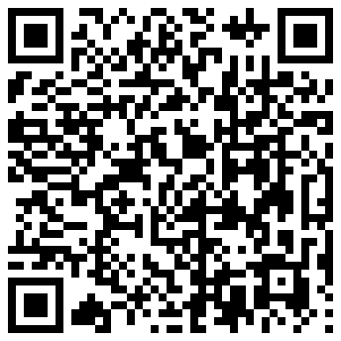
http://livingnewdeal.berkeley.edu/resources/what-was-the-new-deal/
New Deal
1
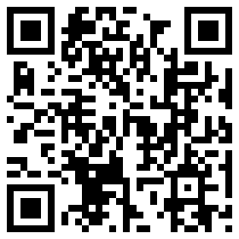
http://www.fdrheritage.org/new_deal.htm
New Deal Initiative: | Description: | Outcome:
2
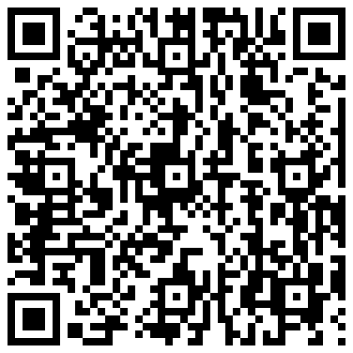
Periodic Table of the New Deal

3

