Lesson Title | Colonies | Teacher | Angela Stringer
Grade Level | 4 | Duration of Lesson | 2 Lessons (60 min each)
Lesson Topic | This lesson students compare North American colonies.
SC Standards and Indicators | S.S. Standard: 4-2 The student will demonstrate an understanding of how the settlement of North America was influenced by the interactions of Native Americans, Europeans, and Africans.  4-2.2: Compare the various European settlements in North America in terms of economic activities, religious emphasis, government, and lifestyles.  ELA Standard: 4-2 The student will read and comprehend a variety of informational texts in print and nonprint formats.  4-2.2 Analyze informational texts to draw conclusions and make inferences.  4-2.5 Use headings, subheadings, print styles, white space, captions, and chapter headings to gain information.  4-2.6 Use graphic features (including illustrations, graphs, charts, maps, diagrams, and graphic organizers) as sources of information.  4-2.8 Analyze informational texts to identify cause-and-effect relationships.  ELA Standard: 4-3 The student will use word analysis and vocabulary strategies to read fluently.  4-3.1 Generate the meaning of unfamiliar and multiple-meaning words by using context clues (for example, those that provide an example or a definition).
Common Core Strategy(ies) addressed | Reading across the curriculum; literacy of print and non-print resources; graphic organizers; constructed response questions; grouping
Academic Vocabulary | Social Studies: missionary, indentured servant, slave, New Spain, New France, England, Catholic, Protestant, Quaker, economic, religious, government, lifestyle, Parliament, monarch, artisan, apprentice
Lesson Materials Needed (attached at end of lesson) | Smart board lesson, rubric, social studies notebooks, handouts
Content Narrative  (What is the background information that needs to be taught to understand the context of the lesson? Be sure to include necessary citations) | Prior to this indicator, students learned about the Land Bridge theory on how the first peoples came to North America. Next, they learned about how these people settled over time throughout the country and developed into Native American cultures. Immediately prior to this lesson, students learned about European explorers (see below).  The following information was taken directly from the S.C. Support Documents:  Indicator 4-1.4: Summarize the accomplishments of the Vikings and the Portuguese, Spanish, English, and French explorers; including, Leif Eriksson, Columbus, Hernando de Soto, Magellan, Henry Hudson, John Cabot, and La Salle.  The motivations for the European explorers were competition between nations, expansion of international trade, and technological advances in shipbuilding and navigation. The accomplishments of the explorers greatly influenced land claims and colonization by European countries.  Leif Eriksson was a Viking from Greenland who sailed the northern Atlantic Ocean and settled briefly in North America, which he called Vinland. The Vikings’ combative relationship with other Europeans however, did not allow them to share their discovery, so North America remained unknown to most Europeans.  Christopher Columbus sailed for Spain looking for a new and faster route to the Spice Islands. Columbus sailed west because the Portuguese controlled the eastern route around Africa. Columbus believed the world was small enough that he could reach the Far East by sailing west. [Columbus was not the first person to believe the world was round. Most educated people of this time held this belief. This is a common misconception.] Columbus did not reach his goal to bring back the many riches from the Far East. Instead he discovered the lands of San Salvador- West Indies and wealth. This provided the gateway of Spanish settlements in North and South America.  Ferdinand Magellan’s expedition was the first to sail around the world. Although Magellan died before the journey was complete, he claimed more lands for Spain. His crew proved that sailing around the world could be achieved, but at a great cost.  Hernando de Soto was a Spanish conquistador who explored throughout the southeastern United States and claimed this land for Spain. As a result, Spanish explorers claimed Florida and the southwest region of what is today the United States and called all of this land New Spain.  John Cabot sailed for England. Cabot was looking for a faster route to the Indies known as the Northwest Passage. Cabot tried to replicate Columbus’ route by sailing west, but hoped to be able to travel in the direction of northwest. The commonly held belief of Northwest Passage, which would link the Atlantic and Pacific Oceans, continued to motivate other explorers even into the 1800s (Lewis and Clark). The route would never be discovered, because such a route does not exist. Cabot sailed near the Arctic Circle, but he had no success. He did however; claim the lands he encountered for England.  Henry Hudson was an explorer who sailed for both the Netherlands and England. In searching for the Northwest Passage, he claimed and mapped what is now New York for the Dutch and lands in Canada for the English. The Hudson River and Hudson Bay are named for him. Consequently, the English claimed the coast of North America based on the explorations of Cabot and called this land Virginia and New England.  The Dutch claimed the area around the Hudson River and established New Netherlands and New Amsterdam in what is today New York. The Dutch later ceded their colonial claims to the British, leading to the establishment of the thirteen original colonies.  Robert LaSalle explored for France. LaSalle explored the Mississippi River to its mouth in the Gulf of Mexico and named the area Louisiana. Consequently, the French explored the St. Lawrence River and the headwaters and the length of the Mississippi River to what is now New Orleans and claimed this land as New France.
Lesson Set
Content Objective(s) | Students will compare the various European settlements in North America in terms of economic activities, religious emphasis, government, and lifestyles.
Literacy Objective(s) | Students will read and comprehend a variety of informational texts in print and non-print formats (primary source documents, articles, and videos).
Lesson Importance | This lesson is significant for students to understand the beginning of our nation and the sequence of events that would set the stage for the American Revolution, the next indicator following the one covered in this lesson.
Connections to prior and future learning | Previous /Future Knowledge:  4-2.2: Compare the various European settlements in North America in terms of economic activities, religious emphasis, government, and lifestyles.  In third grade, students were asked to summarize the motives, activities, and accomplishments of the exploration of South Carolina by the Spanish, French, and English (3-2.2). In grades 7 and 8, students will compare the colonial claims and the expansion of European powers through 1770 (7-1.1). Students will summarize the history of English settlement in New England, the mid-Atlantic region, and the South, with an emphasis on South Carolina as an example of a distinctly southern colony (8-1.3).  Previous /Future Knowledge:  In previous indicators European explorers were taught. (See above background knowledge.)
Anticipatory Set/ Hook (Engage) | Ask students: “Where did the colonists settle once explorers claimed their lands and why?” Review explorers, where they settled, and which country for which they claimed land—background knowledge (Lesson 1).  Tell them that they will be learning about how different countries claimed land, why colonists settled in America, and how they survived in the colonies. Follow the smart board slides each day.

Skill Development
Initial “explain” portion of the lesson. Introduce vocabulary, explain/demonstrate/model the skill required for the literacy objective, introduce content components.
The content portion is only a brief introduction; the bulk of the student learning will take place during the guided practice activity.
Introduce content components | Explain to students that the objective for the lesson is that they will be able to  compare the various European settlements in North America in terms of economic activities, religious emphasis, government, and lifestyles. They will be doing this through discussion, journaling, document analysis, and creating graphic organizers. They will be working both independently and within a small group setting.
“I do”  Skill from objective  introduce/explain/model | Show (introduce) a primary source document and discuss its significance. Explain why we analyze these documents to learn about history from the “source”.  Introduce vocabulary terms - more vocabulary will come later as students analyze documents and uncover important terms, using literacy skills and context clues to figure out the meaning of the terms. Be sure to hit this vocabulary during discussion/ notebooking after document analysis.  Teacher note: Refer to the S.C. Support document for the essential learning on the following:  Day 1: Together, analyze a series of documents showing the economic activities, religious activities, government, and lifestyle of the Spanish colonies. Complete a document analysis sheet. Discuss.

Guided Practice
This is the inquiry portion of the lesson, student-centered & often cooperative learning strategies used, teacher acting as facilitator, also known as Explore.
“We do”  Activity Description  Include student “explore” components and opportunities for them to explain their learning. | Divide the class into small groups by ability level.  Day 1 (English Colonies): Give each group a series of primary source documents (differentiated by readability). Each group will also complete a document analysis sheet on the documents. They will be analyzing the document to infer the economic activities, religious activities, government and lifestyle of the New England, Middle, and Southern Colonies  Group 1: series of New England colonies documents  Group 2: series of Middle Colonies documents  Group 3: series of Southern Colonies documents  Day 2: Group 1 shares out information (documents analysis) on New England colonies. Teacher fills in any missing information & asks guiding questions. The class adds notes to their Venn Diagrams.  Day 3: Group 2 shares out information (documents analysis) on Middle Colonies. Teacher fills in any missing information & asks guiding questions. The class adds notes to their Venn Diagrams.  Day 4: Group 3 shares out information (documents analysis) on New England colonies. Teacher fills in any missing information & asks guiding questions. The class adds notes to their Venn Diagrams.  Day 5: Give students a variety of leveled books to research the French colonies. Have them read to determine economic activities, religious activities, government, and lifestyle of the French colonies. Discuss and add to Venn diagram.
Checking for Understanding-“Informal” Assessment | Teacher will circulate the room and ask critical thinking questions while guiding the students to discuss and how to fill in the analysis sheet. Come back whole group: each group will share their documents and analysis along with any questions this generated for them.

Closure
Teacher will re-visit content and answer students’ questions developed during the Guided Practice component. Summarize the lesson, clarify content, and revisit content and literacy objectives.
Content Solidified | Each day, discuss the “big picture” in looking at all of these documents… make connections with what students saw in pictures, location of colonies with how colonists lived on the land and survived. Fill in any missing gaps. (See smart board). Content comes directly from the S.C. Support Documents).  Highlight vocabulary in notes taken in notebook and have students add illustrations/ diagrams and definitions of vocabulary. Early finishers may write the word in a sentence & illustrate the vocabulary. (differentiation)  *** Review important vocabulary and add to Index in notebook!!  Closure:  - review discussion (See above).  - Brainpop video (See smart board).

Independent Practice
“You Do” | Students will write “1st person” journal entry in the voice of a colonist living in one of the 13 English Colonies. Have them choose which location and include facts from what they’ve learned.

Summative/ “Formal” Assessment
Assessment | Test

Differentiation
During Lesson | Product: You may create partial notes from the Support Document for notebook, if needed.  Extra documents to analyze for early finishers.  Students may use a double Venn Diagram in lieu of Triple Venn. You may also allow them to make a “Double Bubble Thinking Map” in lieu of Triple Venn.  Grouping: grouped by like need to challenge one another and they are given documents based on difficulty of readability.
Assessment | Students will take the assessment during rotations, grouped by need. Some small groups will have the test read to them based on IEP accommodation or need.

Reflection
Lesson Reflection  (What went well in the lesson? What might you do differently the next time you teach it? Evaluate the success of the lesson) | The students enjoyed discussion about the colonies. They also enjoyed analyzing documents but did need a lot of guidance to delve deeper into the photographs and maps. I needed to ask guiding questions to delve deeper and have them infer based on the documents they were analyzing.  Next time I will be sure the students have more background on the colonies and on analysis of documents before giving them documents to analyze. Just be sure to do exactly as this lesson says and go through several documents whole group before moving into small group.  When I first taught this lesson, I planned on teaching the Spanish and French colonies first. I went back to the lesson and placed the French at the end instead.  The first day takes 2 class periods if taught thoroughly.
Materials Needed for Lesson
Lesson Materials and Handouts | All are attached below:

_____________________________
_____________________________
Colonies Document Analysis Sheet
Directions: Complete this sheet by filling in the blanks or answering the questions with complete sentences.
Type of Document: (Circle or Write.)
photograph, artwork, newspaper
article, legal document

Title of the Document:

This document shows (Circle):
economics government

religion lifestyle (day-to-day)

Who was affected by this document or what’s being shown?

Important
Vocabulary

For artworks, illustrations or photographs: Who or what is being shown? - people, places, things, events

What is the mood of the piece?

What questions do you have? _______________________
_______________________________________________
What other observations can you make of this document?
_______________________________________________
What inferences can you make from your observations?
______________________________________________________________________
Are you able to make any text to self, text to world, or text to text connections? Explain.
______________________________________________________________________

Example Documents
Spanish Colonies

Note to teacher: Use these documents to model how to complete the Analysis Sheet. Then, divide students into groups and give them their own primary sources to analyze.

Directions: Click on the below link or type it in the address bar on the computer. Read the text and look for information about the economy of the colony, the religion, government, and day-to-day lifestyle. Add the information to your analysis sheet.

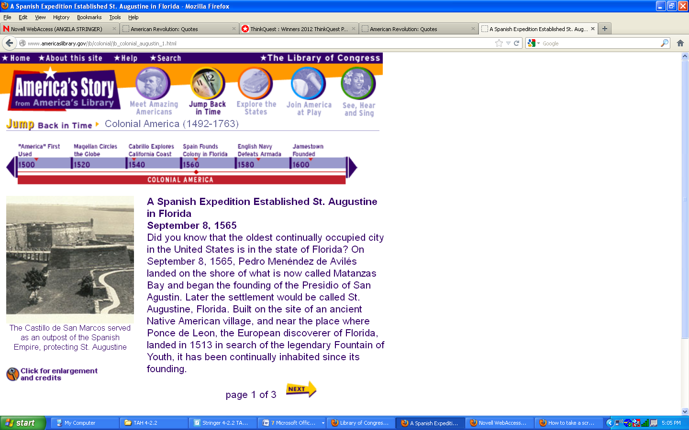
http://www.americaslibrary.gov/jb/colonial/jb_colonial_augustin_1.html

Spanish Colonies

Directions: Analyze the below maps. Think and discuss with your group the economy of the colony, the religion, government, or day-to-day lifestyle. You have to infer! Add the information to your analysis sheet.

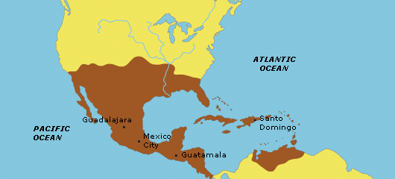
http://www.nps.gov/ethnography/aah/aaheritage/images/NewSpain.gif

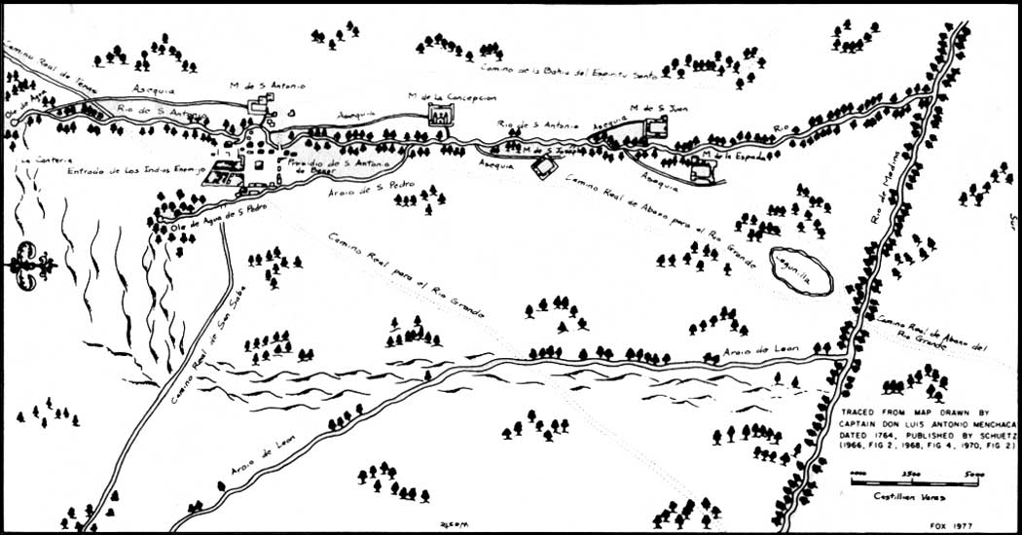
http://www.cr.nps.gov/history/online_books/saan/campbell/images/fig2.jpg

Spanish Colonies

Directions: Click on the below link or type it in the address bar on the computer. Read the text and look for information about the economy of the colony, the religion, government, and day-to-day lifestyle. Add the information to your analysis sheet.

http://www.nps.gov/saan/index.htm
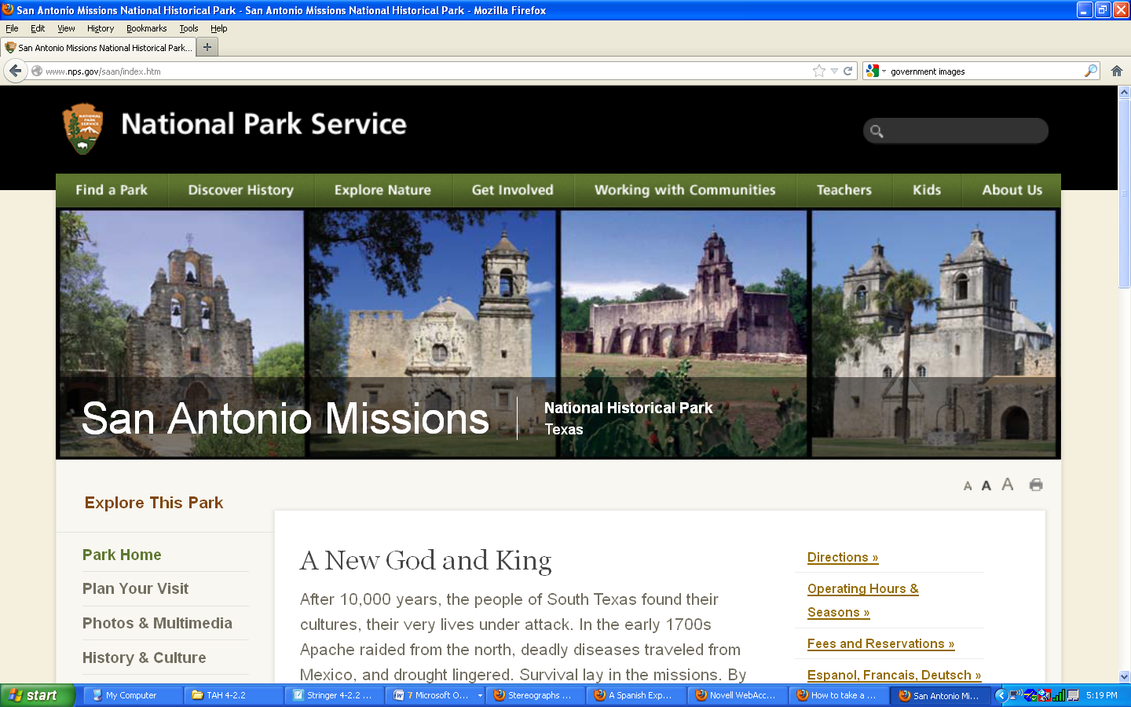

Spanish Colonies

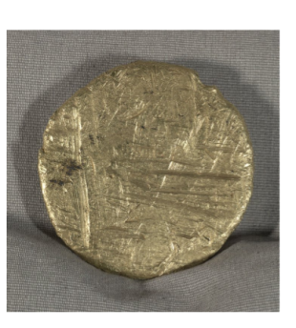Directions: Analyze the below pictures and the description. Think and discuss with your group the economy of the Spanish colonies, the religion, government, or day-to-day lifestyle. You have to infer! Add the information to your analysis sheet.
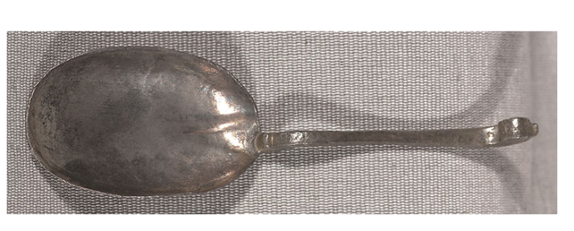

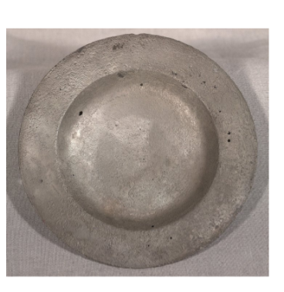
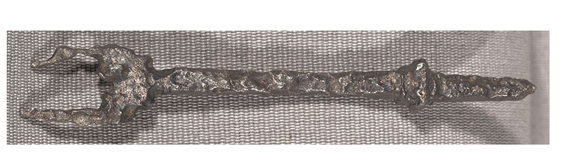

Information below and above images taken from: http://myloc.gov/Exhibitions/EarlyAmericas/AftermathoftheEncounter/CompetitionforEmpire/PiratesandPrivateers/ExhibitObjects/ItemfromaSpanishTreasureShip.aspx

During the centuries of Spanish exploration and colonization, treasure fleets made regular trips to the Americas to deliver merchandise and collect treasures and precious metals. In late summer merchant ships would join their protectors, the war galleons, in Havana to form the treasure fleet for the return to Spain. Often, however, ships were scattered because of bad weather, poor seamanship, or piracy. In early September 1622, Nuestra Señora de Atocha, a galleon carrying tons of Spanish treasure, was wrecked on the Florida coral reefs near the Dry Tortugas, leaving only five survivors. These items were recovered from the site of the wreck.

The Items are: a Silver fork, a Spoon, a Plate, and Gold bullion.
Silver fork, spoon, plate, and gold bullion from the Nuestra Señora de Atocha wreck, 1622. Jay I. Kislak Collection, Rare Book and Special Collections Division, Library of Congress (118.00.01)

Spanish Colonies

Directions: Click on the below link or type it in the address bar on the computer. Read the text and look for information about the economy of the colony, the religion, government, and day-to-day lifestyle. Add the information to your analysis sheet.

http://www.nps.gov/history/spca/sites/Spcohe~1.htm
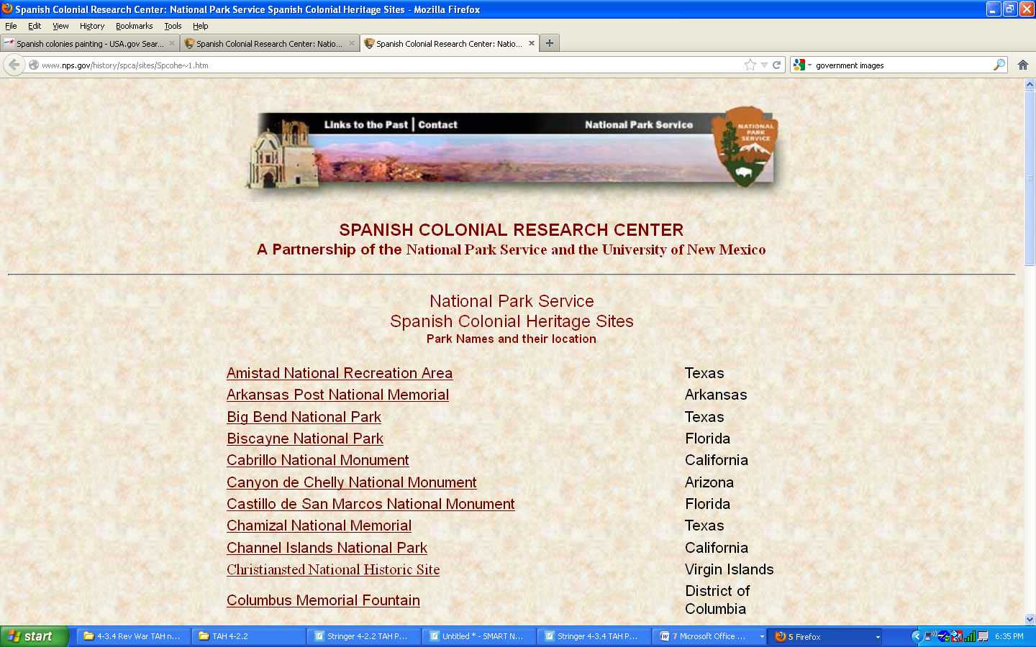

New England Colonies

Directions: Analyze the below photograph. Think and discuss with your group the economy of the New England colonies, the religion, government, or day-to-day lifestyle. You have to infer! Add the information to your analysis sheet.
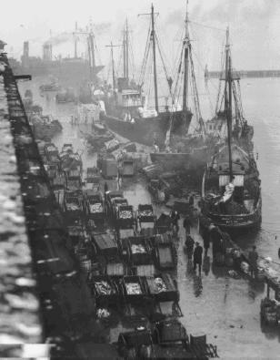

http://www.nefsc.noaa.gov/history/stories/groundfish/images/sfb2.jpg

New England Colonies
Directions: Analyze the below map. Imagine what it would be like to live in the New England colonies. Think and discuss with your group the economy of the New England colonies, the religion, government, or day-to-day lifestyle. You have to infer! Add the information to your analysis sheet.

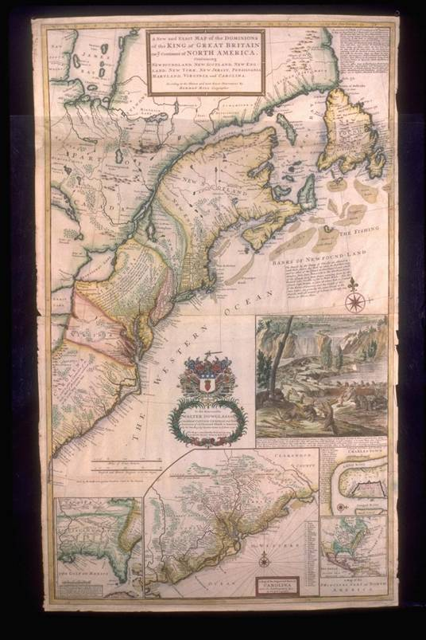
http://tah1.cusd.com/projects/pathfinders/05.04_files/image004.jpg

New England Colonies
Directions: Analyze the below picture. Think and discuss with your group the economy of the New England colonies, the religion, government, or day-to-day lifestyle. You have to infer! Add the information to your analysis sheet.

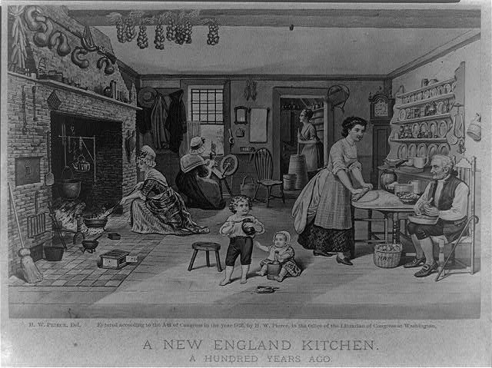
http://www.loc.gov/pictures/item/2006691541/

New England Colonies
Directions: Click on the below link or type it in the address bar on the computer. Read the text and look for information about the economy of the colony, the religion, government, and day-to-day lifestyle. Add the information to your analysis sheet.

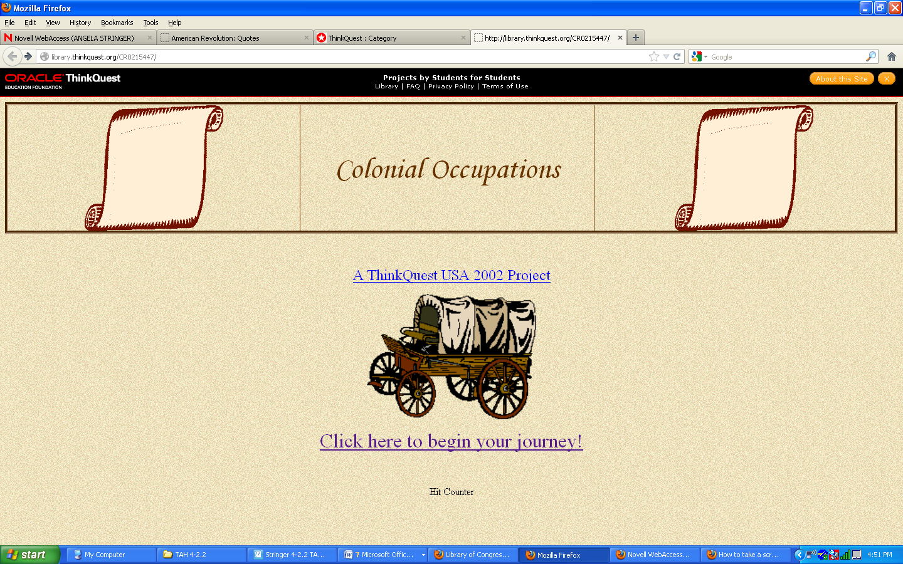
http://library.thinkquest.org/CR0215447/

New England Colonies
Directions: Click on the below link or type it in the address bar on the computer. Read the text and look for information about the economy of the colony, the religion, government, and day-to-day lifestyle. Add the information to your analysis sheet.

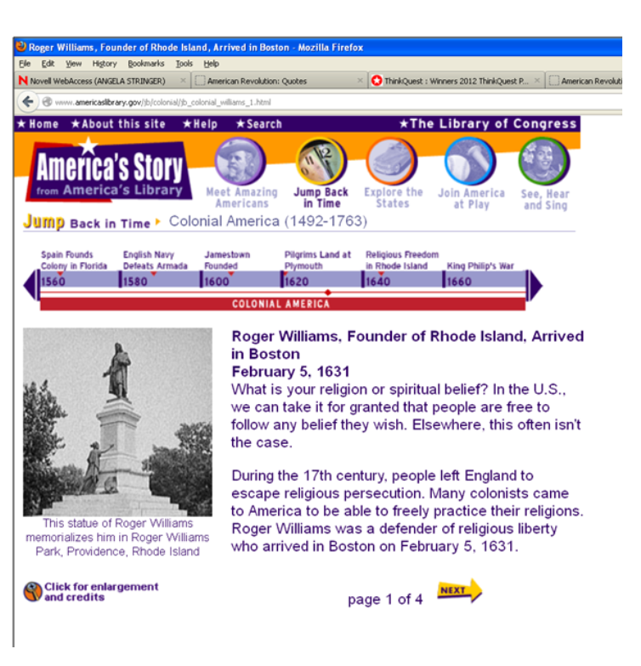
http://www.americaslibrary.gov/jb/colonial/jb_colonial_williams_1.html

Middle Colonies

Directions: Analyze the below picture. Think and discuss with your group the economy of the Middle colonies, the religion, government, or day-to-day lifestyle. You have to infer! Add the information to your analysis sheet.
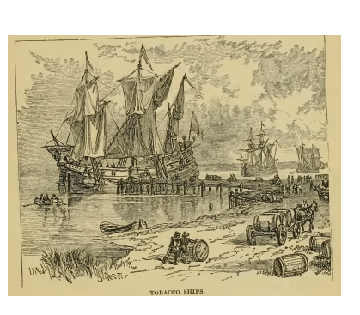

http://lccn.loc.gov/rc%2001002411

Middle Colonies

Directions: Click on the below link or type it in the address bar on the computer. Read the text and look for information about the economy of the colony, the religion, government, and day-to-day lifestyle. Add the information to your analysis sheet.

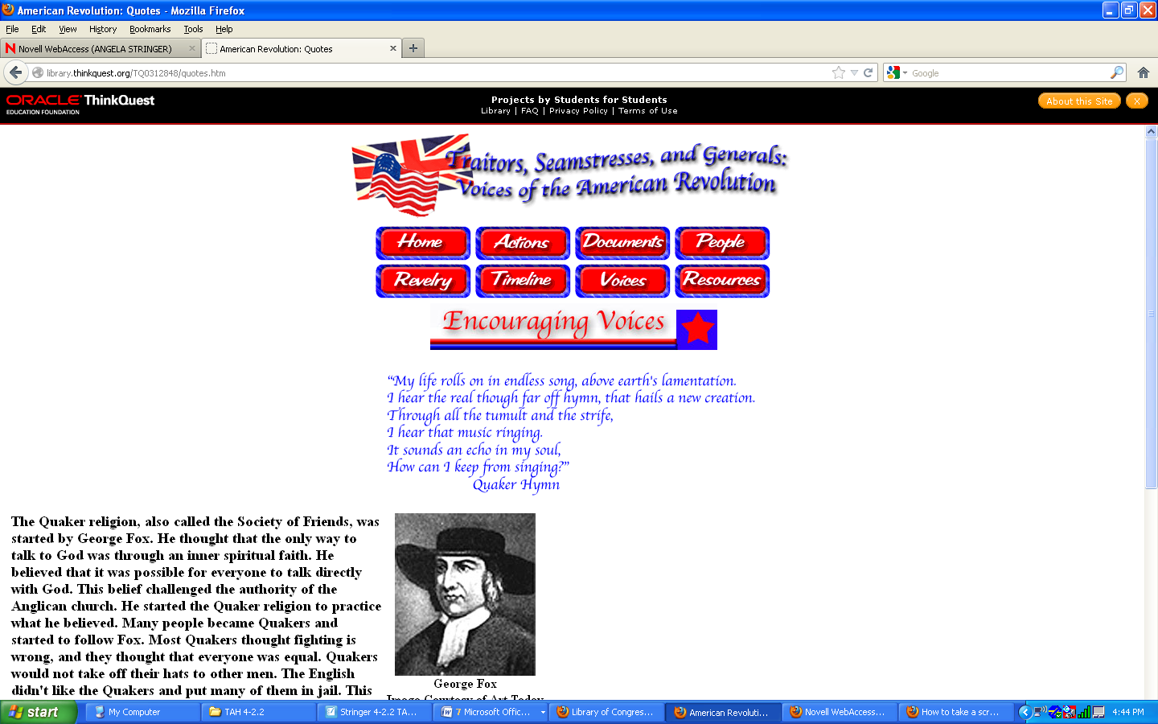
http://library.thinkquest.org/TQ0312848/quotes.htm

Middle Colonies

Directions: Click on the below link or type it in the address bar on the computer. Read the text and look for information about the economy of the colony, the religion, government, and day-to-day lifestyle. Add the information to your analysis sheet.

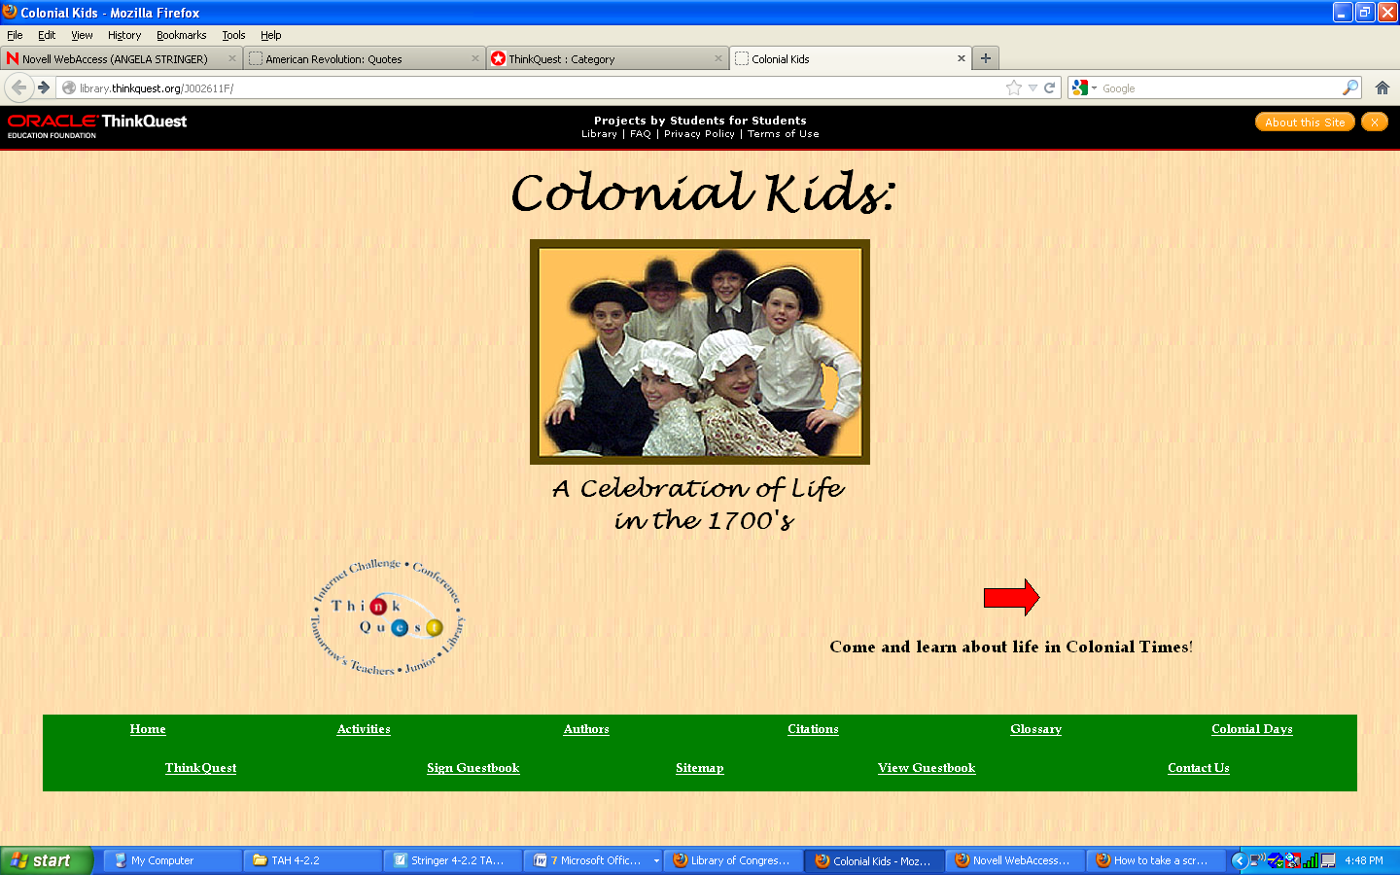
http://library.thinkquest.org/J002611F/

Middle Colonies

Directions: Analyze the below map. Imagine what it would be like to live in the Middle Colonies. Think and discuss with your group the economy of the Middle Colonies, the religion, government, or day-to-day lifestyle. You have to infer! Add the information to your analysis sheet.

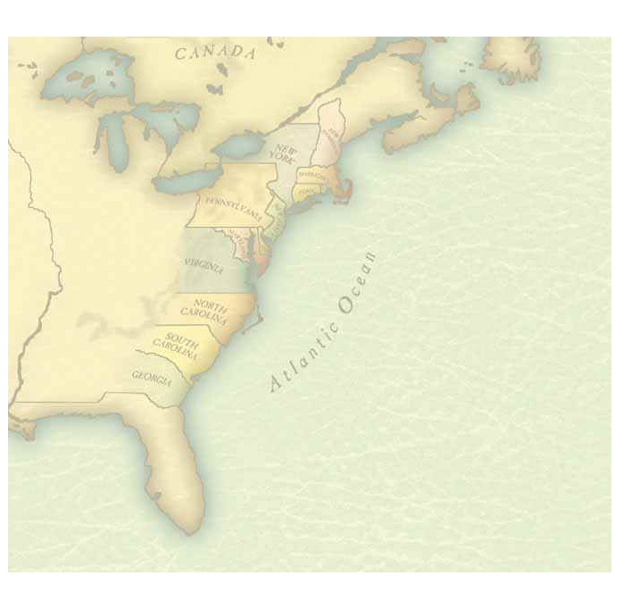

http://schools.bcsd.com/fremont/Graphics/geography/13colonies.jpg

Southern Colonies

Directions: Analyze the below pictures. Think and discuss with your group the economy of the Southern colonies, the religion, government, or day-to-day lifestyle. You have to infer! Add the information to your analysis sheet.

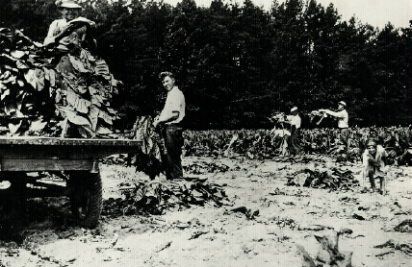

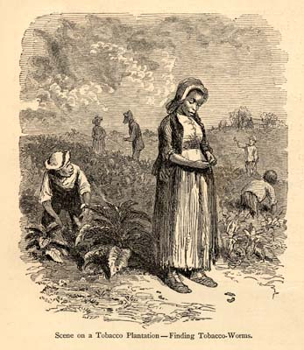http://msa.maryland.gov/msa/speccol/photos/lowe/images/1477-5212.jpg

http://www.chesapeakebay.net/images/blog/tobaccoplantation.jpg

Southern Colonies

Directions: Analyze the below pictures. Think and discuss with your group the economy of the Southern colonies, the religion, government, or day-to-day lifestyle. You have to infer! Add the information to your analysis sheet.

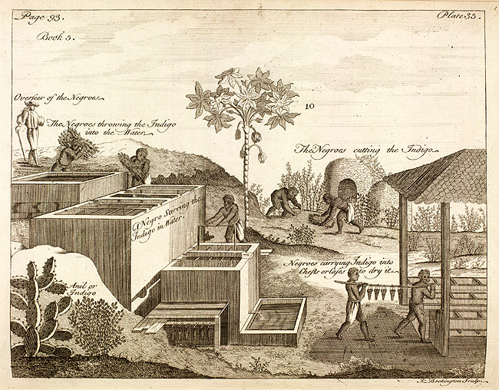

http://www.sil.si.edu/PAID/fullsize/SIL-007-033/SIL7-33-01.jpg

Index
A | B | C | D
E | F | G | H
I | J | K | L
M | N | O | P
Q | R | S | T
U | V | W | XYZ

4-2.2 Comparing Colonies
KEY
Map Identification: 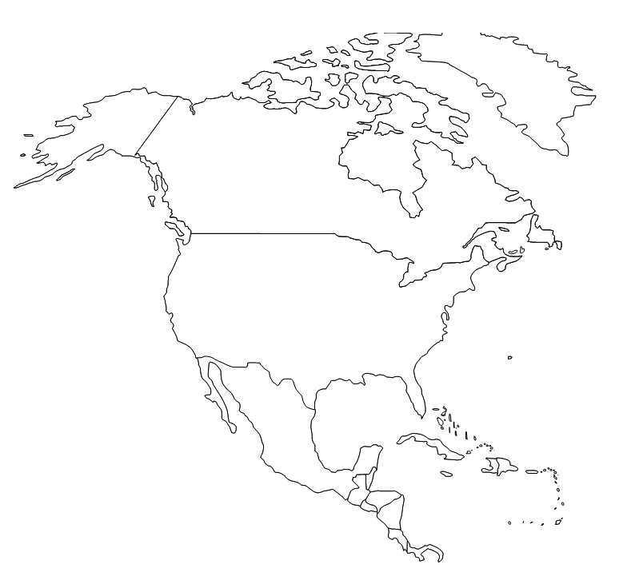Shade in accurately using the key as a guide. Label on the lines and draw an arrow to each location on the map: New Spain, New England, and New France.

- ________________

2. ________________

3. ________________

Key
New Spain English Colonies
New France

Multiple Choice Directions: Fill in the bubble next to the correct answer.
4. These colonists settled modern-day Florida and southwestern parts of North America.
0 Spanish 0 French
0 English 0 Dutch

5. These colonists settled along the Atlantic Coast of North America and were motivated by religious freedom or economic opportunity.

0 Spanish 0 French
0 English 0 Dutch
6. These colonists settled Quebec on the St. Lawrence River along the Mississippi River.
0 Spanish 0 French
0 English 0 Dutch
7. These colonists founded the colony of New Netherland but did not continue to establish additional colonies.
0 Spanish 0 French
0 English 0 Dutch

Matching: Match the terms in the right column with the matching descriptions on the left. Write the corresponding letter in the blank beside the description.
Descriptions | Terms
8. _____ They exported tobacco, rice, and indigo.  9. _____ They exported foods to the Caribbean and other European countries.  10. _____ They exported lumber and built ships to support their economics.  11. _____ They traded fur. | - New France  - New England Colonies  - English Middle Colonies  - English Southern Colonies

Short Answer: Write your response to the question in complete sentences.
- Where did the Dutch settle and what happened to their colony? (Make sure to mention who took their colony and what 2 colonies did New Netherland become?)

The Dutch founded the colony of New Netherland but did not continue to establish additional colonies. They were eventually forced by the English to give up their colony and the land that was formerly the Dutch colony of New Netherland became the English colonies of New York and New Jersey.

- Explain what the colonies and the mother country did to try to become economically stronger than their European rivals.
The colonies imported natural resources that were plentiful in North America and exported goods from the mother country to the colonies.

Directions: Fill in the blank with the correct term from the word box below. Each term will only be used once.
- Catholicism -English - French and Spanish

- Middle and Southern Colonies - Protestant

- Catholicism The Spanish missionaries and French settlers converted the native Americans to this religion.
- French and Spanish Very little self government was allowed in their colonies.
- Middle and Southern Colonies Most of the men and women here worked on family farms with indentured servants or slaves working alongside them.
- English They allowed their colonies to create colonial legislative branches .
- Protestant English settlers were mostly this religion.

T/F- Correct the false statements to make them true.
- The Englishmen who settled Jamestown, Virginia in 1607 originally hoped to find gold, but soon began to plant cash crops such as tobacco. True
- Catholics who settled in Pennsylvania practiced religious tolerance by allowing others to practice their religion as they chose. False, Quakers settled …_________ __________________________
- The English were absolute monarchs while the Spanish and French kings had a tradition of legislative representation in Parliament. False, The Spanish and French kings were absolute monarchs while the English had a tradition of legislative representation in Parliament.

- The French established a fur trade with Native Americans so they could sell fur pelts to Europe for a profit. True

Directions: Create a “Double Bubble” thinking map or a Venn diagram comparing and contrasting 2-3 colonies. Choose from the following: Spanish, English, or French. You may also choose from: New England, Middle, or Southern Colonies. Add labels and a caption to explain your diagram. Make sure you have a total of at least 10 descriptions.

- Caption:__________________________________________________

___________________________________________________________

4-2.2 Comparing Colonies Test
Map Identification: Shade in accurately using the key as a guide. Label on the lines and draw an arrow to each location on the map: New Spain, New England, and New France.

- ________________

2. ________________

3. ________________

Key
New Spain English Colonies
New France

Multiple Choice Directions: Fill in the bubble next to the correct answer.
4. These colonists settled modern-day Florida and southwestern parts of North America.
0 Spanish 0 French
0 English 0 Dutch
5. These colonists settled along the Atlantic Coast of North America and were motivated by religious freedom or economic opportunity.

0 Spanish 0 French
0 English 0 Dutch
6. These colonists settled Quebec on the St. Lawrence River along the Mississippi River.
0 Spanish 0 French
0 English 0 Dutch
7. These colonists founded the colony of New Netherland but did not continue to establish additional colonies.
0 Spanish 0 French
0 English 0 Dutch

Matching: Match the terms in the right column with the matching descriptions on the left. Write the corresponding letter in the blank beside the description.
Descriptions | Terms
8. _____ They exported tobacco, rice, and indigo.  9. _____ They exported foods to the Caribbean and other European countries.  10. _____ They exported lumber and built ships to support their economics.  11. _____ They traded fur. | - New France  - New England Colonies  - English Middle Colonies  - English Southern Colonies

Short Answer: Write your response to the question in complete sentences.
- Where did the Dutch settle and what happened to their colony? (Make sure to mention who took their colony and what 2 colonies did New Netherland become?)

________________________________________________________

________________________________________________________

________________________________________________________
- Explain what the colonies and the mother country did to try to become economically stronger than their European rivals.

________________________________________________________

________________________________________________________

________________________________________________________

________________________________________________________

Fill in the Blank: Fill in the blank with the correct term from the word box below. Each term will only be used once.
- Catholicism -English - French and Spanish

- Middle and Southern Colonies - Protestant

- _______________________ The Spanish missionaries and French settlers converted the native Americans to this religion.
- _______________________ Very little self government was allowed in their colonies.
- _______________________ Most of the men and women here worked on family farms with indentured servants or slaves working alongside them.
- _______________________ They allowed their colonies to create colonial legislative branches .
- _______________________ English settlers were mostly this religion.
T/F- Correct the false statements to make them true.
- The Englishmen who settled Jamestown, Virginia in 1607 originally hoped to find gold, but soon began to plant cash crops such as tobacco. ___________
_________________________________________________________
- Catholics who settled in Pennsylvania practiced religious tolerance by allowing others to practice their religion as they chose. ______________
_________________________________________________________
- The English were absolute monarchs while the Spanish and French kings had a tradition of legislative representation in Parliament. ___________
_________________________________________________________
- The French established a fur trade with Native Americans so they could sell fur pelts to Europe for a profit. _________________________________
_________________________________________________________

Venn Diagram:Create a “Double Bubble” thinking map or a Venn diagram comparing and contrasting 2-3 colonies. Choose from the following: Spanish, English, or French. You may also choose from: New England, Middle, or Southern Colonies. Add labels and a caption to explain your diagram. Make sure you have a total of at least 5 descriptions.

- Caption:__________________________________________________

___________________________________________________________
3 – Diagram includes 2-3 colonies, with labels, a caption and 5 descriptions.
2- Diagram includes 2-3 colonies but is missing either the labels or a caption. 5 Descriptions are included.
1- Diagram includes 2-3 colonies but is missing either the labels or a caption and has less than 5 descriptions.
0-Response includes less than 2 colonies and is missing labels, and/ or a caption and has less than 5 descriptions.

Works Cited
South Carolina Department of Education (2011). 4-1.4, 4-2.2, South Carolina
Standards Support Documents (pp.7-14). Columbia: South Carolina Department of Education.

Copyright Free Documents and Images:

Library of Congress Documents:

Title: A New England Kitchen. A Hundred Years Ago
ARC ID #: 2006691541

Copyright free photographs used came from: http://www.usa.gov
http://www.msc.navy.mil/sealift/2006/December/graphics/chriscolumbus.jpg
http://www.nefsc.noaa.gov/history/stories/groundfish/images/sfb2.jpg
http://tah1.cusd.com/projects/pathfinders/05.04_files/image004.jpg
http://www.nps.gov/ethnography/aah/aaheritage/images/before1763.gif
http://schools.bcsd.com/fremont/Graphics/geography/13colonies.jpg
http://msa.maryland.gov/msa/speccol/photos/lowe/images/1477-5212.jpg
http://www.nps.gov/ethnography/aah/aaheritage/images/NewSpain.gif
http://www.cr.nps.gov/history/online_books/saan/campbell/images/fig2.jpg
http://www.sil.si.edu/PAID/fullsize/SIL-007-033/SIL7-33-01.jpg

Other copyright free photos came from Smart notebook gallery.

Websites used:
http://library.thinkquest.org/J002611F/
http://www.nps.gov/saan/index.htm
http://www.nps.gov/history/spca/sites/Spcohe~1.htm

