Lesson Title | Internment Camps: Violation of Constitutional Rights? | Teacher | JAMES MALTESE
Grade Level | 11th | Duration of Lesson | One Class period (90 Minutes)
Lesson Topic | World War II: Japanese Internment
SC Standards and Indicators | USHC-7.2 Evaluate the impact of war mobilization on the home front, including consumer sacrifices, the role of women and minorities in the workforce, and limits on individual rights that resulted in the internment of Japanese Americans.
Common Core Strategy(ies) addressed | Grade 11-12: Cite specific textual evidence to support analysis of primary and secondary sources, connecting insights gained from specific details to an understanding of the text as a whole.
Academic Vocabulary | Internment, executive order
Lesson Materials Needed (attached at end of lesson) | Notes for 7.2; Websites for Executive Order, Civil Liberties Act, Apology Letter from Bill Clinton, Nuremburg Laws, and Nuremberg Decisions
Content Narrative  (What is the background information that needs to be taught to understand the context of the lesson? Be sure to include necessary citations) | The students will have already learned about the reasons why the United States broke from her position as isolationist to become interventionist. The December 1941 attack on Pearl Harbor was the lightning rod for involvement, however, students will understand the significance of the seas and the naval conflict between the US and Germany that occurred before Congress declared war on Japan.  They would have already analyzed a collection of Dr. Seuss political cartoons, which criticized the US for not getting involved in the European conflict sooner, particular in terms of the Holocaust and Japanese aggression in the South Pacific. Obviously disillusionment from World War I and the America First movement would be major talking points before this lesson.  Additionally, the students would have reviewed the evolution of the Holocaust from concentration to death camps. They will need this knowledge and understanding to compare what the Nazi’s did to the Jews to what could have potentially happened to Japanese Americans had the US not been so successful in the South Pacific. It is important to understand that the Holocaust was possible because of legalized ethnic discrimination. The internment of Japanese Americans was ethnic discrimination. Fortunately, that discrimination did not become violent and murderous.
Lesson Set
Content Objective(s) | SWBAT evaluate the limits on individual rights that resulted in Japanese internment.
Literacy Objective(s) | SWBAT to translate and analyze World War II era legislation.
Lesson Importance | The lesson is directly correlated to the USHC standards for the state of South Carolina. Understanding the significance of the limitation of Constitutional rights is essential to the student’s ability to understand the continuously changing meaning of “democracy in America.” Democracy is the root of the course and the subject of which all standards can be connected.
Connections to prior and future learning | Additionally, understanding these limitations during World War II will connect the students to recent US policies of detainment and legislation like the Patriot Act.
Anticipatory Set/ Hook (Engage) | - Do Now: How would you respond if the federal government ordered you to sell all of your possessions and move into a heavily guarded camp with people from a common ethnic background? Would any of your rights be violated by this government action? Do you think other Americans would be outraged by these actions? Explain.

Skill Development
Initial “explain” portion of the lesson. Introduce vocabulary, explain/demonstrate/model the skill required for the literacy objective, introduce content components.
The content portion is only a brief introduction; the bulk of the student learning will take place during the guided practice activity.
Introduce content components | During the discussion of the “Do Now” students will be exposed to the terms internment and executive order. There will be a direct instruction lesson on the domestic impact of the war. The end of this lecture will focus on Japanese Internment camps.
“I do”  Skill from objective  introduce/explain/model | - Nuremberg Law Rewrite and Violation Identification:  Teacher Model: Analysis of Reich Citizenship Law and identify its main points and how it violates natural rights (violation of US Constitution even though it was a German law)  2. Direct Instruction: Domestic impact of War  3. Teacher Model: Response to Events: Court Decisions from Nuremberg Trials: Analysis of court decision from Nuremberg trials.

Guided Practice
This is the inquiry portion of the lesson, student-centered & often cooperative learning strategies used, teacher acting as facilitator, also known as Explore.
“We do”  Activity Description  Include student “explore” components and opportunities for them to explain their learning. | - Identifying the main points of the Nuremberg Laws and the possible violations of Constitutional rights. (Pretend Nuremberg Laws were subject to US Constitution)  - Small Group: Sections from the Executive Order (ID Main points and how each point is a violation of the Constitution)  - Groups will share out before continuing to the independent practice.
Checking for Understanding-“Informal” Assessment | -Main Idea Summaries of legislation/executive orders.  Interactive Lecture Questions  How did the war impact the consumer at home?  What role did women and minorities play in the war?  Why were Japanese Americans interned during WWII? What did this represent?

Closure
Teacher will re-visit content and answer students’ questions developed during the Guided Practice component. Summarize the lesson, clarify content, and revisit content and literacy objectives.
Content Solidified | SEE FORMAL ASSESSMENT
Independent Practice
“You Do” | Independent: Analyze Response: Civil Liberties Act of 1988/Apology Letter from President Clinton in 1993. (Summary of each section/each paragraph of letter)  ID the Constitutional violations addressed by the Civil Liberties Act.
Summative/ “Formal” Assessment
Assessment | Short Answer Question: Evaluate the US decision to intern Japanese Americans during World War II. Use the questions below to help guide your answer.  Given the state of war and the heightened tension created by the Pearl Harbor attack, was the US response to intern Japanese Americans justifiable? What type of precedent could these actions set? Were there significant similarities to the Nazi camps in Europe created to house and murder Jews? Was the response to internment by the US government adequate? Should government officials have been held accountable for these Civil Rights violations?

Differentiation
During Lesson | Shorter selections to interpret/reword;  Complete legislative analysis with entire class then have the student’s finish the response portion on their own.
Assessment | Choose 3 of the guided questions to answer as oppose to considering all the questions in the writing assessment.

Reflection
Lesson Reflection  (What went well in the lesson? What might you do differently the next time you teach it? Evaluate the success of the lesson) | The breakdown of the Executive Order and Civil Liberties Act went well. Students understood the purpose of the exercise and the significance of the legislation in relation to the era in which it was produced.  Students understood the Civil Rights violations and were able to effectively argue for or ask Japanese internment based on their evaluation of the historical events.  The next time I teach this unit, I am going to divide the class into 3 sections. One section will study the displacement of Native Americans, one will study the internment of Japanese Americans, and the last group will evaluate the treatment of Middle Eastern Americans in the 10s. Each group will summarize various pieces of government legislation and court cases associated with the event. Then students will be forced to either defend the limitations of freedoms (within the framework of a specific historical context) or defend the concept that constitutional freedoms are absolute.

Materials Needed for Lesson
Lesson Materials | Power Point (USHC 7.2) (see attached photos of slides)  Websites for Teacher:  Nuremburg Translated-  http://www.ushmm.org/wlc/en/article.php?ModuleId=10007903  Decisions from Nuremburg-  http://law2.umkc.edu/faculty/projects/ftrials/nuremberg/alstoetter.htm#U.S.A.%20v.%20ALSTOETTER%20ET%20AL%20%28The%20Justice%20Cases%29:  Constitution:  http://www.archives.gov/exhibits/charters/constitution_transcript.html  Websites for students:  Executive Order 9066/Civil Liberties Act 1988/ Clinton Apology Letter 1993  http://www.pbs.org/childofcamp/history/documents.html  Constitution:  http://www.archives.gov/exhibits/charters/constitution_transcript.html

Direct Instruction Materials
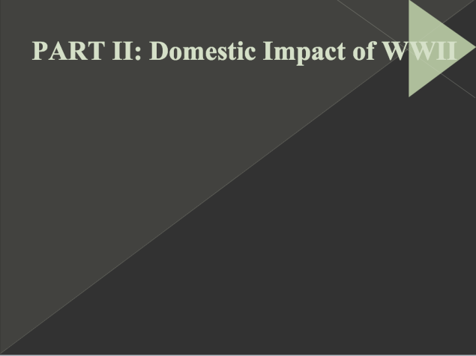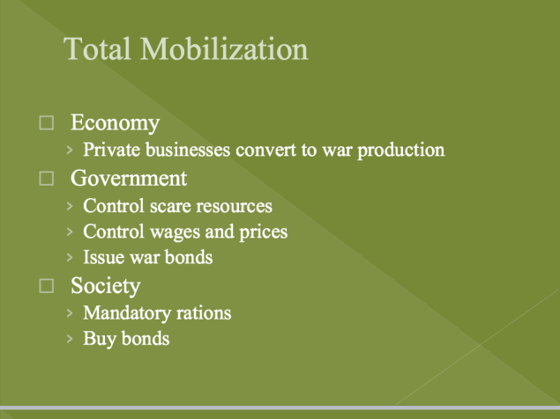
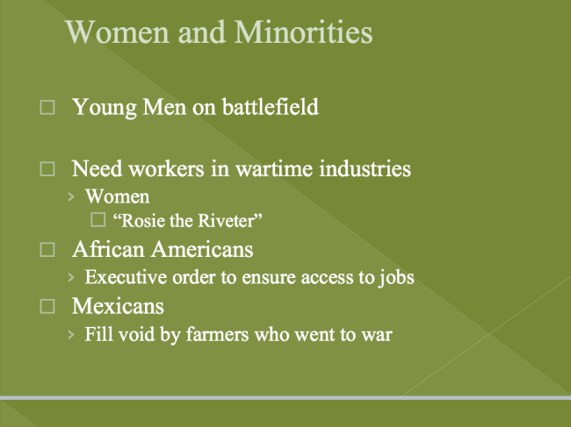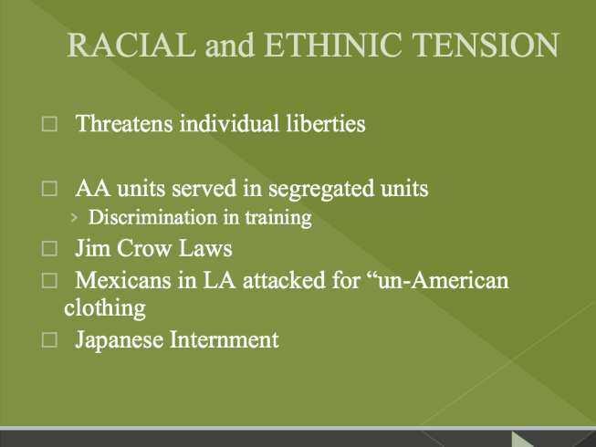Rubrics
Main Idea/Constitutional Connection
A: Two to three complete sentences summarizing the main idea; Article, section, and quote from Constitution that highlights the violation found in the main idea.
B: One to two complete sentences summarizing the main idea; Article, section, and quote from Constitution that highlights the violation found in the main idea.
C: Bullet point summary of main idea; Article and section from Constitution that highlights the violation found in the main idea.
D: One surmising bullet point; Article from Constitution that highlights the violation found in the main idea.
F: incomplete/incoherent/incorrect summary; No Constitutional connection.
Formal Assessment
A: At least a four paragraph essay with an evaluating thesis; three to four direct quotes from internment legislation/response; at least 4 supporting statements of thesis.
B: A four paragraph essay with an evaluating thesis; one to two direct quotes from internment legislation/response; at least 3 supporting statements of thesis.
C: Three paragraph essay with a working thesis; one direct quote from internment legislation/response.
D; Less than three paragraphs; unclear thesis; Zero to one quote
F: One Paragraph; no quotes; incomplete

