Lesson Title | Checks and Balances | Teacher | Mr. Curt Wisor
Grade Level | 8th Grade SC History | Duration of Lesson | 1 or 2- 60 Minute classes

Lesson Topic | This lesson provides an explanation of how each branch holds power over the other so as to keep one branch from becoming too powerful. This lesson demonstrates how this process works and some of the checks each branch has over the other.
SC Standards and Indicators | 8-3.3: Explain the basic principles of government as established in the US Constitution.
Common Core Strategy(ies) addressed | RH-1: Cite specific textual evidence to support analysis of primary and secondary sources.  RH-3: Identify key steps in a text’s description of a process related to history/social studies  RH-4: Determine the meaning of words and phrases as they are used in a text, including vocabulary specific to domains related to history/social studies.  RH-8: Distinguish among fact, opinion, and reasoned judgment in a text.
Academic Vocabulary | Limited Government, Separation of Powers, & Checks and Balances
Lesson Materials Needed (attached at end of lesson) | 1.) BrainPOP Video: Branches of Government (Free Video) www.brainpop.com  2.) Checks and Balances Chart  3.) Comic Book Activity & Examples  All handouts are attached at the end of lesson
Content Narrative  (What is the background information that needs to be taught to understand the context of the lesson? Be sure to include necessary citations) | Here is SC’s support document that chronicles this indicator and served as the foundation of the lesson:  From 1783 until 1789, the United States was governed by the Articles of Confederation. However, the Articles of Confederation government, which derived its powers from the states, was too weak to meet the needs of the new nation. To meet those deficiencies, the Constitution was drawn up in 1787, ratified in 1788, and went into effect in 1789.  The Constitution of the United States of America established a limited government based on power shared between the national and state governments. The Bill of Rights provided a written guarantee of individual rights. The Constitution is the highest law in the United States. All other laws must conform to the Constitution. Each state also has a constitution. The constitutions of the states are the highest law for that state, but the United States Constitution is the supreme law of the land.  The basic principles of American government include:  · _Popular Sovereignty- (Democracy) The authority for government flows from the people. (Amendment IX and the Preamble)  · _Individual Rights- Unalienable rights are guaranteed to all citizens in the Preamble and the Bill of Rights.  · _Federalism-The federal system divides governmental powers between national government and the governments of the states. (10th Amendment)  · _Separation of Powers - The structure of the new national government established three separate branches of government to limit the power of any one branch. The Legislative Branch is the United States Congress which makes the laws. Congress is a two-house legislature. The Judicial Branch consists of federal courts. The highest court is the Supreme Court which determines if laws made by Congress are constitutional. The Executive Branch is headed by the President and carries out the laws. The Vice President and the Secretaries of all departments are also in the Executive branch.  · _Checks and balances - Each branch can check the power of the other. These checks keep any one branch from gaining too much power (Articles I, II, III). An example of checks and balances is the process by which a bill becomes a law. The bill must be passed by both houses of the Congress. Then the President may sign it or veto it. If the bill is vetoed, then the Congress may override the president’s veto with a two thirds vote.  · _Limited Government - Powers of the government are restricted by the Constitution as stated in Articles I, II, and III and by the Bill of Rights which protects the rights of the individual against excessive power by the government.  · _Representative Democracy (republicanism) - The constitution recognizes that the authority of the government derives from “We, the People.” Voters hold the sovereign power but elect representatives to exercise power for them, including the President, Senators and Representatives (The Preamble and Article I, II).  Students should know that most state governments mirror the organization of the national government, with an executive, legislative, and judicial branch including the concepts listed above, such as checks and balances.  http://ed.sc.gov/agency/se/Teacher-Effectiveness/Standards-and-Curriculum/documents/Grade8.pdf
Lesson Set
Content Objective(s) | 1. Students will be able to define checks and balances and demonstrate examples of how each branch has checks over the other.
Literacy Objective(s) | WH-2: Write informative/explanatory texts, including the narration of historical events, scientific procedures/ experiments, or technical processes.  WH-4: Produce clear and coherent writing in which the development, organization, and style are aappropriate to task, purpose, and audience.
Lesson Importance | This lesson is critical to understanding the founding fathers’ concept of limited government. This is a perfect case study to show that the new United States had a legitimate fear of a large government and that they took action in trying to make a small (in power) national government.
Connections to prior and future learning | The students should have already learned about the constitutional convention and studied articles 1-3 of the constitution (separation of powers). This lesson will help students further expand their knowledge on how limited government works and it will help students understand why future court cases are turned down/ratified.
Anticipatory Set/ Hook (Engage) | Post this bell ringer on the board:  -- List the three branches of government and explain each branch’s duty.  (Answers- Legislative: Makes Laws, Executive: Enforces Laws, Judicial: Interprets Laws)

Skill Development
Initial “explain” portion of the lesson. Introduce vocabulary, explain/demonstrate/model the skill required for the literacy objective, introduce content components.
The content portion is only a brief introduction; the bulk of the student learning will take place during the guided practice activity.
Introduce content components | Post learning objective on the board and have students copy it into their notes (if you do a notebook system). Discuss learning objective and make them aware of all components of the lesson (“I Do,” “We Do,” “You Do”)
“I do”  Skill from objective  introduce/explain/model | 1.) Show students the BrainPOP video titled “Branches of Government.”  Post this informational text on your board and have the students respond to the prompt that follows. You can discuss their answers as a whole group, guiding your lesson to the guided practice session that follows:  Checks and Balances  American History  James Madison believed that the government powers must be divided into separate areas and that each part should have a limited amount of power and control. James Madison felt this was important for many reasons, one he refers to in this quote, "If men were all angels, no government would be necessary. If angels were to govern men, neither external nor internal controls on government would be necessary."  Essentially Madison was referring to a commonly know term in today's society, "checks and balances". Checks and Balances refer to the fact that each branch of government has many ways to check on the power of other branches. For example, the President can veto a bill, Congress can over-ride a veto and the Supreme Court can declare a law unconstitutional. Madison also believed that the members of each branch should be independent. He addressed the possible problems of how power could be divided equally but gave many facts that supported his idea that a divided government system would in turn be a safer way to conduct governing.  Madison also touched on the social aspect on how a divide government would make the "weaker" and the "stronger" man more secure, in this quote he states "by a like motive, to wish for a government which will protect all parties, the weaker as well as the more powerful."  Madison had a extremely strong passion for how government should be ran and the most effective way of doing so, which is why now in 2004 and many years prior, the system of checks and balances have existed.  Question: Why didn’t the founding fathers just create a single branch of government? Wouldn’t that be easier? Explain your answer in 3-4 complete sentences.

Guided Practice
This is the inquiry portion of the lesson, student-centered & often cooperative learning strategies used, teacher acting as facilitator, also known as Explore.
“We do”  Activity Description  Include student “explore” components and opportunities for them to explain their learning. | Distribute copies of the checks and balances chart provided.  This graphic organizer is useful for the students because they now have a visual to go by. The teacher should briefly explain what each branch can do to the other. It is the students’ task at this time to choose which two branches they will use in the Comic Book Activity.
Checking for Understanding-“Informal” Assessment | Ask these guided questions to your students that go along with the checks and balances chart:  1.) After observing the chart, does it seem like one branch is still more powerful than the other?  2.) What does this system of checks and balances say about the construction of the federal government? (closely linked together, limited in power, founding fathers clearly feared government becoming too strong)

Closure
Teacher will re-visit content and answer students’ questions developed during the Guided Practice component. Summarize the lesson, clarify content, and revisit content and literacy objectives.
Content Solidified | Define what checks and balances are and provide one example of one branch having power over the other.

Independent Practice
“You Do” | The students will create a comic strip that demonstrates how one branch has power over the other. Examples are provided below to help the students generate ideas.

Summative/ “Formal” Assessment
Assessment | Students will write a 1-paragraph response to this prompt:  “Given your knowledge of the system of checks and balances, explain why the founding fathers included this system as an individual’s guard against the federal government.”

Differentiation
During Lesson | Students are given extended time to complete comic book project.  They may be assigned only three boxes to compete.  Notes provided.  Read close read to class.
Assessment | Students answer what checks and balances are and how they keep one branch from becoming too powerful.

Reflection
Lesson Reflection  (What went well in the lesson? What might you do differently the next time you teach it? Evaluate the success of the lesson) | PROS  -- Engaging video and straight-forward explanation of content (in 4 mins!)  -- Good activities for the Garner’s Spectrum of MI.  -- Pretty light lesson for teachers.  CONS  -- Independent practice assignment may be too challenging for 8th graders?  -- Students who do not perceive themselves to be artistically inclined will not enjoy the activity.  -- May need an extra class to help with the comic activity.
Materials Needed for Lesson
Lesson Materials and Handouts | Checks and Balances Chart for Guided Practice  http://www.kminot.com/art/charts/branches.jpg  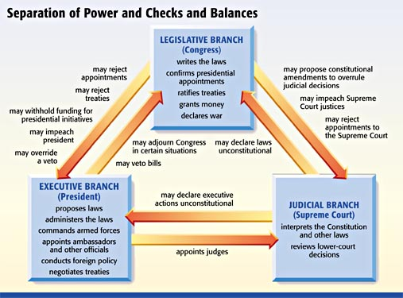  Comic Book Examples:  http://www.acslaw.org/files/9.17.09%20Book%20Talk%20-%20GRAPHIC4.JPG  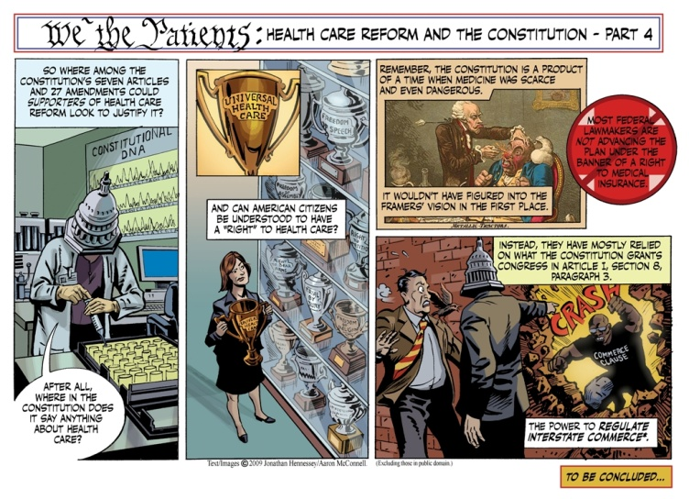  http://www.acslaw.org/files/9.11.09%20Book%20Talk%20-%20GRAPHIC1.JPG  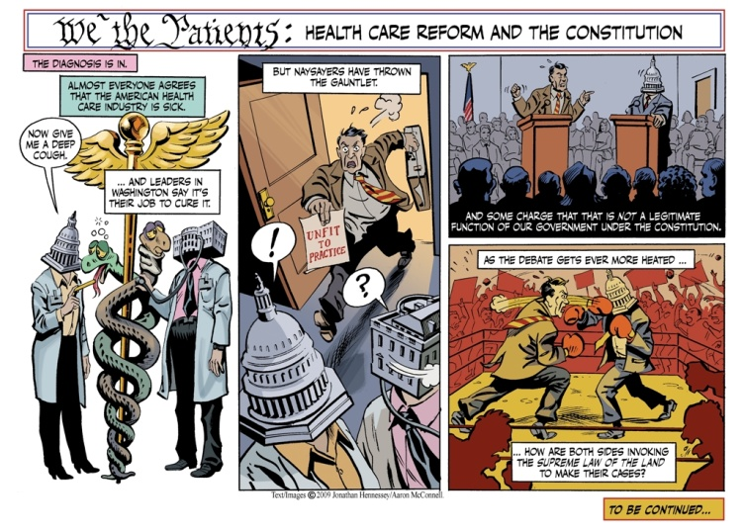  Constitutional Comic Book Activity  Believe it or not, the Constitution defends us as much as any superhero does! In fact, Articles I-III of the Constitution grant the executive, legislative, and judicial branches a whole bunch of “superpowers.” Thus, your job for this activity is to create a comic strip that demonstrates a superpower of one of the three branches of government (exec., leg., or judicial). In other words, you’re going to make a comic strip about either Article I, II, II, or a combination of both. In addition, you’ll demonstrate your “checks and balance” powers against another branch of government (the villain). I want you to include the following in your comic:  Choose the Article you want to do. Your choices are Article I, II, or III  Your comic should have a superhero that reflects whichever article you choose  The comic should show the superhero’s powers. For example, if you do Article I, you may want to show your hero’s ability to declare war. Try to include as many powers as possible  The comic should have a conflict with another branch of government. This other branch will be the villain. What checks and balances will you use to defeat the villain?  Make sure the story has a beginning, middle, and end. Or, in English terms, a rising action, conflict, and falling action.  Be creative with this assignment. I don’t care if it’s three panes, 5 panes, or 20 panes. Just make sure to include all of the above things!

